#SG_Malaysia

This note is shared by some of #sg_malaysia study group member.

Artificial Intelligence  
course Material

Contents

Notes Contributors 4

Module 2 : Lesson 2 6

1. Introduction to AI In Business 6

1.1. Overview 6

1.2. What is AI 6

1.3. What can AI do? 6

1.4. The AI Universe 7

1.5. Why Deep Learning 7

1.6. Industry Application 9

1.7. Affecting Industry 9

1.8. Machine Learning Concept 10

1.9. Supervised Learning 10

1.10. Unsupervised Learning 11

1.11. Supervised vs Unsupervised Learning 13

1.12. Reinforcement Learning 14

1.13. Neural Networks 17

MODULE 2 : LESSON 3 23

2. USING AI AND MACHINE LEARNING IN BUSINESS 23

2.1. OVERVIEW 23

2.2. AI APPROACH 23

2.3. BUSINESS NEEDS 25

2.4. THE BUSINESS CASE 25

2.5. Identify AI value 26

2.6. Project Statement 27

2.7. Breaking it All Down 27

2.8. Metrics 27

2.9. Metrics Example: LinkedIn 28

2.10. Need for an AI 28

2.11. Additional Notes 28

2.12. Things Need to Be Remembered 29

2.13. Key roles 29

2.14. Project management 30

Module 3 - Lesson 1 32

3. Creating a Dataset 32

3.1. Answering Questions With Data 32

3.2. As Good As the Data 32

3.3. Data Fit 34

3.4. Data Completeness 35

3.5. Appen's Data Annotation Platform 36

3.6. Case Study: Parking Signs & Figure Eight 36

3.7. The Platform 36

3.8. Job Design 37

3.9. Instructions & Example 38

3.10. Test Questions 38

3.11. Auditing Results 40

3.12. Planning for Failure 41

3.13. Planning for Longevity 41

Module 4: Lesson 1 42

4. Build A Model 42

4.1. Overview of Modeling 42

4.2. Activation Functions 42

4.3. Modeling, Key Points 43

4.4. Training Data 43

4.5. A pet model 43

4.6. Training Data is Key 44

4.7. Training Data Summary 47

4.8. Model Evaluation 48

4.9. Transfer Learning 50

4.10. Automated Machine Learning 53

4.11. Automated ML vs Custom Modeling 54

4.12. Transfer Learning and Automated Machine Learning Summary 54

4.13. Outro 54

Module 5: Lesson 1 55

5. MEASURING BUSINESS IMPACT AND MITIGATING BIAS 55

5.1. Introduction to Business Impact 55

5.2. Case Studies and Challenges 55

5.3. Measuring Success 56

5.4. Outcome vs Output 57

5.5. Chatbot Example 57

5.6. A/B testing & Versioning 58

5.7. Monitor Bias 59

5.8. Addressing Unwanted Bias 59

5.9. Continuous Learning 60

5.10. Spam Filter 61

5.11. Model Optimization & Staleness 61

5.12. Compliance and Ethics 62

5.13. Privacy-First Approach 62

5.14. Scaling a Product 63

5.15. Summary of Skills 64

Module 5: Lesson 2 65

6. CASE STUDY 65

# Notes Contributors

|  |  |  |  |
| --- | --- | --- | --- |
| **Module** | **Topic** | | **Contributor (slack name)** |
| Module 2 | Lesson 2 | overview | ooi liching |
|  |  | what is AI |
|  |  | what can AI do? |
|  |  | The AI universe |
|  |  | Why deep learning |
|  |  | Industry Application |  |
|  |  | Affecting Industry |  |
|  |  | Machine Learning Concept | Brizza Abadier |
|  |  | Supervised Learning |  |
|  |  | Unsupervised Learning |  |
|  |  | Reinforcement Learning |  |
|  |  | Neural Network |  |
|  |  | Current state of AI | Mark Jeremy Essa |
|  |  | Outro |  |
|  | Lesson 3 | overview | aditya sankalp |
|  |  | AI Approach |
|  |  | Business need |
|  |  | The Business Case |
|  |  | Project Statement |  |
|  |  | Breaking it All Down |  |
|  |  | Metrics | Alex Soh |
|  |  | metrics example: LinkedIN |  |
|  |  | Need for AI |  |
|  |  | Need for AI: Example |  |
|  |  | Things to remember |  |
|  |  | Team overview | moheshchandran |
|  |  | Key roles |  |
|  |  | Project Management |  |
| Module 3 | Lesson 1: | Answering Questions with Data |  |
|  |  | As good as the data |  |
|  |  | Data Fit | Peter |
|  |  | Data Completeness |  |
|  |  | Case Study: Parking Signs & Figure Eight |  |
|  |  | The Platform |  |
|  |  | Job Design |  |
|  |  | Instruction and example |  |
|  |  | Test Question |  |
|  |  | Auditing result | Ong kam siong |
|  |  | planning for failure |  |
|  |  | Planning for Longevity |  |
| Module 4 | Lesson 1 | Overview of Modeling | Tirtadwipa Manunggal |
|  |  | Activation Functions |
|  |  | Modeling, Key Points |  |
|  |  | Training Data |  |
|  |  | A Pet Model | Seungju Lee |
|  |  | Training Data is Key |  |
|  |  | Training Data Summary |  |
|  |  | Model Evaluation | Nithiyaa Ghanis |
|  | Model Evaluation, Key Points |  |
|  | Transfer Learning |  |
|  |  | Automated ML |  |
|  |  | Automated ML vs Custom Modeling | Etendra Verma |
|  |  | Automated ML, Summary |  |
|  |  | Outro |  |
| Module 5: | Lesson 1: | Case Studies and Challenges |  |
|  |  | Measuring Success |  |
|  |  | Outcome vs. Output |  |
|  |  | Chatbot Example | aditya sankalp |
|  |  | A/B Testing & Versioning |  |
|  |  | Monitor Bias |  |
|  |  | Addressing Unwanted Bias |  |
|  |  | Continuous Learning |  |
|  |  | Spam Filter |  |
|  |  | Model Optimization & Staleness | aditya sankalp |
|  |  | Compliance and Ethics |  |
|  |  | Privacy-First Approach |  |
|  |  | Scaling a Product |  |
|  | Lesson 2 | Intro & AI Product Development |  |
|  |  | Identify the Business Problem |  |
|  |  | Video Annotation Problem |  |
|  |  | Prototype & Impact | moheshchandran |
|  |  | Real-Data Prototype |  |
|  |  | Test, Refine -> Final Product |  |
|  |  | Release, Measure, Update |  |
|  |  | Always Learning |  |

# Module 2 : Lesson 2

# Introduction to AI In Business

## Overview

* AL technology has the potential to rapidly change our world for the better.
* Example like improving outcomes for patients, able to scale customer service, reducing drought and water usage and etc.

## What is AI

* AI stands for Artificial Intelligence, more recently the abbreviation can also stand for Augmented Intelligence.
* “Artificial Intelligence is the science and engineering of making computers behave in ways that, until recently we thought required human intelligence.” – Andrew Moore, 2017

## What can AI do?

* Facial recognition that used to recognize faces by social media. Computer can easily recognize individual people with emotion and even micro expressions that people might not aware of.
* Automatic text recognition that used to automate expense reporting by taking pictures of the receipts.
* Computer vision technology using semantic segmentation can take every pixel in an image and assign it to a particular object.
* For application perspective, computer vision is often used in social media use case. Big brands will use it to do sentiment analysis and natural language processing.
* Speech recognition is used but tricky in terms of human level computation in real-world environments. It has challenges like:
* Noisy environments
* Accented speech
* Speaking styles and languages with limited training data
* Understanding speech
* All different types of audio recognition that not just transcribing speech, such as recognizing failures by listening to engines.
* Natural language processing that has technique such as filtering out hate speech in social media platforms.
* AI also can be used to give advice on the quality of your writing.

## The AI Universe

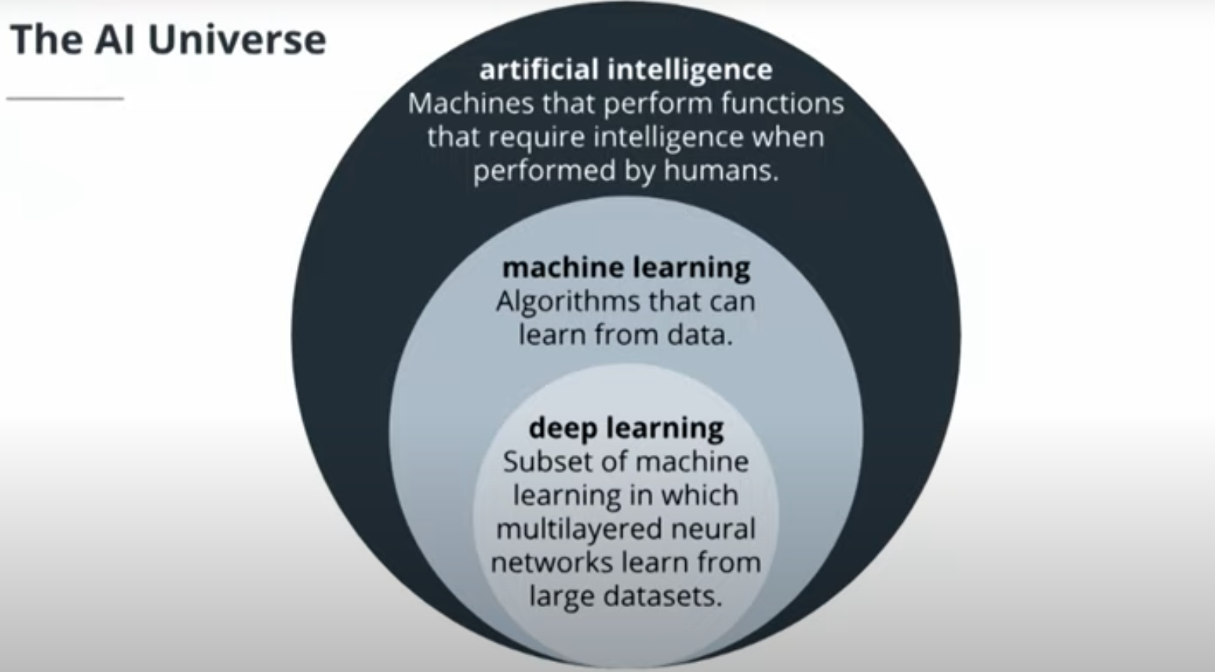

* “[The term AI] is aspirational, a moving target based on those capabilities that humans possess but which machines do not.” – Zachary Lipton

## Why Deep Learning

* Deep learning can process and learn from much, much more data than previous approaches, which with the right data, can really improve the performance of a model against a desired outcome.
* AI is so relevant ***now*** because of three factors:
* Compute power
* Data availability
* Cost
* Supercomputers measure their performance in FLOPS (floating point operations per second – which computers use to do any calculation). Compute power nowadays is a lot more to compare decades ago
* The amount of data being created is growing exponentially, which is hard for human to process but is really easy and really good for deep learning and machine learning techniques.
* Cost has come down drastically over time, speaking of accessing the compute power and data. Running large-scale computations required for deep learning techniques is a lot more accessible for a lot more people.

Quiz

1. What is Machine Learning? (Choose 3 Answers)
2. Artificial Intelligence
3. Machine Learning
4. Data Statistics
5. Deep Learning

Answer: a, b, d

1. Deep Learning is a subfield of Machine Learning.
2. TRUE
3. FALSE

Answer: a

3. Artificial Intelligence is superset of ________________ & _____________________ .

1. Machine Learning & Neural Networks
2. Machine Learning & Deep Learning
3. Deep Learning & Neural Networks

Answer: b

## Industry Application

1. How will AI affect industry?

“…AI is the new electricity” – Andrew Ng

* Add $15.7 trillion to global economy by 2030 (PWC)
* Labour productivity improvements and product enhancements (PWC)

1. Sectors with great potential

* Retail/E-commerce: pricing and promotion and customer service management
  + Such as password reset activities
  + Better search result and newsletter
* Consumer goods: supply-chain management, demand forecasting
  + Better routing of goods and services
* Finance: marketing and sales, assessing and managing risk
  + How do I know when someone will likely to get married so that I can share them different insurance?

## Affecting Industry

1. Sense and Decide: Blue River Technology

* 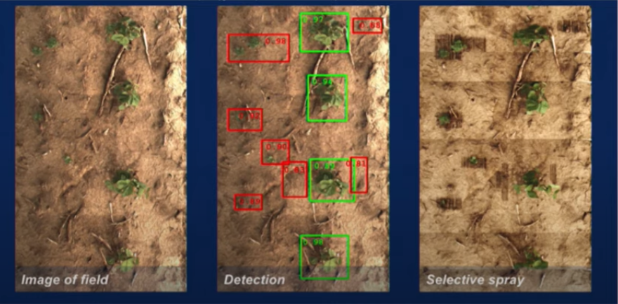Technology to put on tractors to distinguish weed vs plant to help them spray out the herbicide on the weeds which helps them reduce the usage of herbicide by 90%

## Machine Learning Concept

1. What is machine learning?

* It’s a branch of Artificial Intelligence; computer algorithms that improve automatically through experience (Tom Mitchell, Professor and Former Chair of Machine Learning Department of Carnegie Mellon University)

1. Machine Learning Techniques

* Supervised Learning – uses pre-labelled data to train the model to predict new outcomes for information that hasn’t been exposed to before.
  + Classification
  + Regression
* Unsupervised Learning – uses non-labelled data and self organizes to predict patterns or outcomes such as clustering or associations
  + Clustering
  + Association
* Reinforcement Learning – is giving feedback to an algorithm when it does something right or wrong based on a discrete outcome, this can either be in:
  + Real-time
  + Offline

## Supervised Learning

1. Supervised Learning is what most of machine learning and production today is actually using

* It’s mapping inputs to a particular output

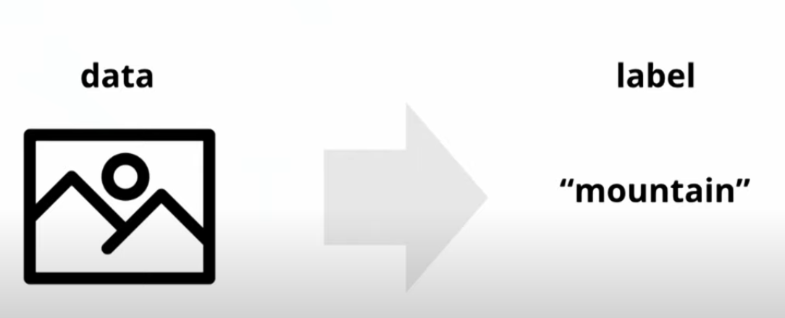

* Example can be the image can be the input data and label is the output (for Classification)

1. Types of Supervised Learning

* Classification: Categorical outcome, categorizing unstructured data into particular categories or classes.
* Regression: the output variable in a regression is numerical or continuous whereas for classification it is discrete

1. Applications

* Image classification
* Optical character recognition
* Face recognition
* Sentiment analysis
* Natural language processing
* Machine translation
* Audio transcription
* Event detection

## Unsupervised Learning

1. Unsupervised learning finds pattern in data.
2. Clustering

* It mainly deals with finding a structure or pattern in a collection of uncategorized data. Clustering algorithms will process your data and find natural clusters(groups) if they exist in the data. You can also modify how many clusters your algorithms should identify. It allows you to adjust the granularity of these groups.

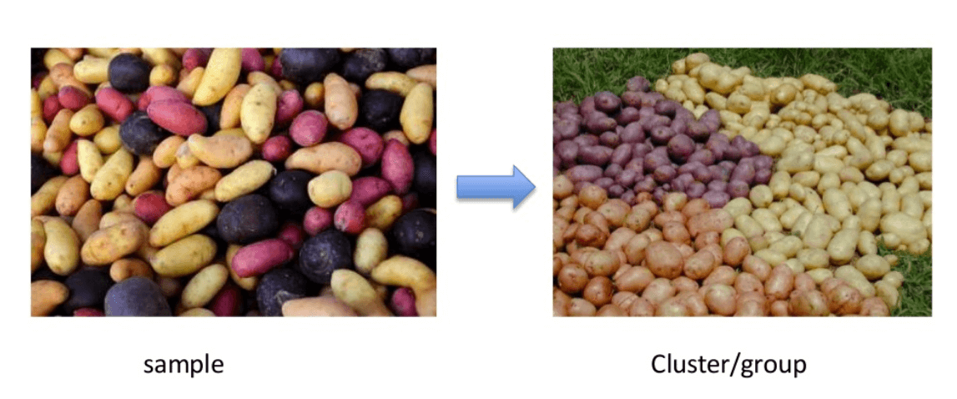

* Different Types of Clustering:
  + Exclusive (partitioning) - data are grouped in such a way that one data can belong to one cluster only.
    - Example: K-means
  + Agglomerative - every data is a cluster. The iterative unions between the two nearest clusters reduce the number of clusters.
    - Example: Hierarchical clustering
  + Overlapping - fuzzy sets is used to cluster data. Each point may belong to two or more clusters with separate degrees of membership. Here, data will be associated with an appropriate membership value.
    - Example: Fuzzy C-Means
  + Probabilistic - uses probability distribution to create the clusters
    - Example: Following keywords
      * "man's shoe."
      * "women's shoe."
      * "women's glove."
      * "man's glove."
    - can be clustered into two categories "shoe" and "glove" or "man" and "women."

1. Association

* Association rules allow you to establish associations amongst data objects inside large databases. This unsupervised technique is about discovering interesting relationships between variables in large databases. For example, people that buy a new home most likely to buy new furniture.

1. Applications

* E-commerce website: i.e. find the common customer’s journey to help retain customers
* Clustering automatically split the dataset into groups base on their similarities
* Anomaly detection can discover unusual data points in your dataset. It is useful for finding fraudulent transactions
* Association mining identifies sets of items which often occur together in your dataset
* Latent variable models are widely used for data pre-processing. Like reducing the number of features in a dataset or decomposing the dataset into multiple components

## Supervised vs Unsupervised Learning

|  |  |  |
| --- | --- | --- |
| **Parameters** | **Supervised machine learning technique** | **Unsupervised machine learning technique** |
| Process | In a supervised learning model, input and output variables will be given. | In unsupervised learning model, only input data will be given |
| Input Data | Algorithms are trained using labelled data. | Algorithms are used against data which is not labelled |
| Algorithms Used | Support vector machine, Neural network, Linear and logistics regression, random forest, and Classification trees. | Unsupervised algorithms can be divided into different categories: like Cluster algorithms, K-means, Hierarchical clustering, etc. |
| Computational Complexity | Supervised learning is a simpler method. | Unsupervised learning is computationally complex |
| Use of Data | Supervised learning model uses training data to learn a link between the input and the outputs. | Unsupervised learning does not use output data. |
| Accuracy of Results | Highly accurate and trustworthy method. | Less accurate and trustworthy method. |
| Real Time Learning | Learning method takes place offline. | Learning method takes place in real time. |
| Number of Classes | Number of classes is known. | Number of classes is not known. |
| Main Drawback | Classifying big data can be a real challenge in Supervised Learning. | You cannot get precise information regarding data sorting, and the output as data used in unsupervised learning is labeled and not known. |

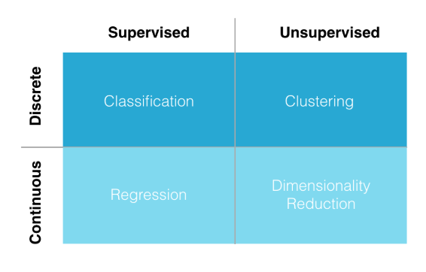

## Reinforcement Learning

1. It’s also another category for unsupervised learning, which concerns how machine learning agents ought to take actions in an environment so as to maximize a specific outcome
2. a machine learning method that is concerned with how software agents should take actions in an environment. Reinforcement Learning is a part of the deep learning method that helps you to maximize some portion of the cumulative reward. This neural network learning method helps you to learn how to attain a complex objective or maximize a specific dimension over many steps.

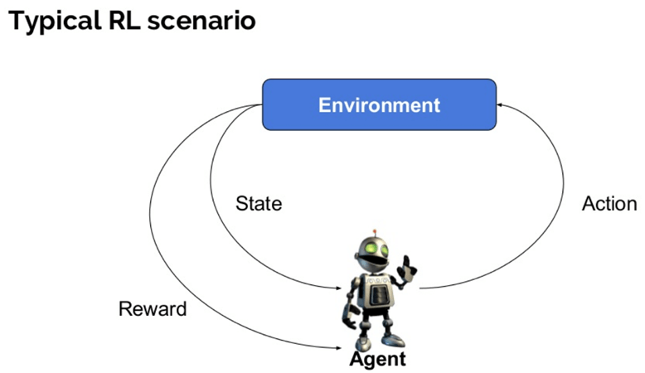

1. Here are some important terms used in Reinforcement AI:

* *Agent*: It is an assumed entity which performs actions in an environment to gain some reward.
* *Environment (e)*: A scenario that an agent has to face.
* *Reward (R)*: An immediate return given to an agent when he or she performs specific action or task.
* *State (s)*: State refers to the current situation returned by the environment.
* *Policy (π)*: It is a strategy which applies by the agent to decide the next action based on the current state.
* *Value (V)*: It is expected long-term return with discount, as compared to the short-term reward.
* *Value Function*: It specifies the value of a state that is the total amount of reward. It is an agent which should be expected beginning from that state.
* *Model of the environment*: This mimics the behaviour of the environment. It helps you to make inferences to be made and also determine how the environment will behave.
* *Model based methods*: It is a method for solving reinforcement learning problems which use model-based methods.
* *Q value or action value (Q)*: Q value is quite similar to value. The only difference between the two is that it takes an additional parameter as a current action.

1. Reinforcement Learning Algorithms

* Value-Based - In a value-based Reinforcement Learning method, you should try to maximize a value function V(s). In this method, the agent is expecting a long-term return of the current states under policy π.
* Policy-based - In a policy-based RL method, you try to come up with such a policy that the action performed in every state helps you to gain maximum reward in the future.
  + Two types of policy-based methods are:
    - Deterministic: For any state, the same action is produced by the policy π.
    - Stochastic: Every action has a certain probability, which is determined by the following equation. Stochastic Policy : n{a\s) = P\A, = a\S, =S]
* Model-Based - In this Reinforcement Learning method, you need to create a virtual model for each environment. The agent learns to perform in that specific environment.

1. Types of Reinforcement Learning

* Positive - It is defined as an event, that occurs because of specific behaviour. It increases the strength and the frequency of the behaviour and impacts positively on the action taken by the agent. This type of Reinforcement helps you to maximize performance and sustain change for a more extended period. However, too much Reinforcement may lead to over-optimization of state, which can affect the results.
* Negative - defined as strengthening of behaviour that occurs because of a negative condition which should have stopped or avoided. It helps you to define the minimum stand of performance. However, the drawback of this method is that it provides enough to meet up the minimum behaviour.

1. One chat bot from Microsoft called “Tay” had gone awry because this type of learning can be quite powerful and might learn wrong things when not there’s no human in the loop
2. Human in the loop (HITL) refers to having a human-moderator or data annotator that can help with quality control of a product
3. Applications

* Robotics for industrial automation.
* Business strategy planning
* Machine learning and data processing
* It helps you to create training systems that provide custom instruction and materials according to the requirement of students.
* Aircraft control and robot motion control

Quiz:

Which of the following statements are incorrect:

1. Reinforcement Learning is also an unsupervised learning
2. Having human in the loop is not necessary especially when the data are getting bigger because it will cost more and AI helps to be more cost-effective
3. Supervised learning is a complex method compared to unsupervised learning
4. Facial recognition is part of unsupervised learning
5. Regression has continuous output variable that makes it a part of unsupervised learning
6. All of the above

Answer : B, C, D, E

References:

<https://www.guru99.com/supervised-machine-learning.html>

<https://www.guru99.com/unsupervised-machine-learning.html>

<https://www.guru99.com/reinforcement-learning-tutorial.html>

## Neural Networks

### What is a Neural Network?

“A neural network is a series of algorithms that endeavours to recognize underlying relationships in a set of data through a process that mimics the way the human brain operates. In this sense, neural networks refer to systems of neurons, either organic or artificial in nature. Neural networks can adapt to changing input; so the network generates the best possible result without needing to redesign the output criteria” – James Chen

As per the definition above, in the lesson 2: Chapter 13, the lesson states that usually neutral networks makes decisions based on weighing evidence. Usually the inputs are Yes/No questions while the outputs are also Yes/No questions.

### Example

In lesson, the tutor gives a question where it is based on an relatable question. In this case, neural can come in to assist with the decision making.

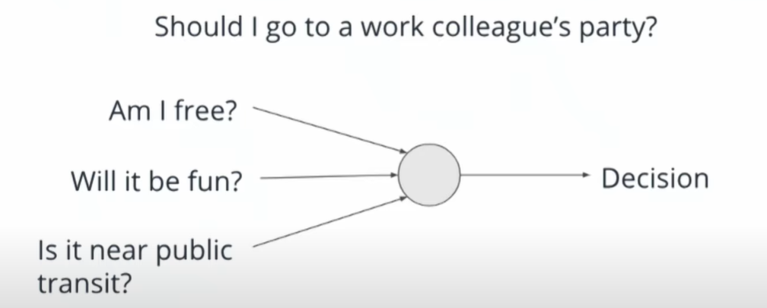

Usually making this decision can be much more complicated than just the one shown above so threshold and weights are introduced to this image,

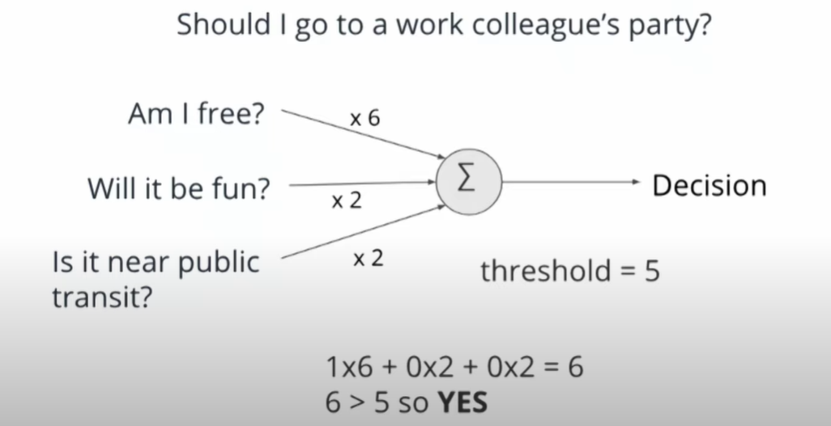

But because of the fact that the threshold is leaning more toward whether you are free, the tutor increased the threshold/changed the weights around in order to have the other choices matter too.

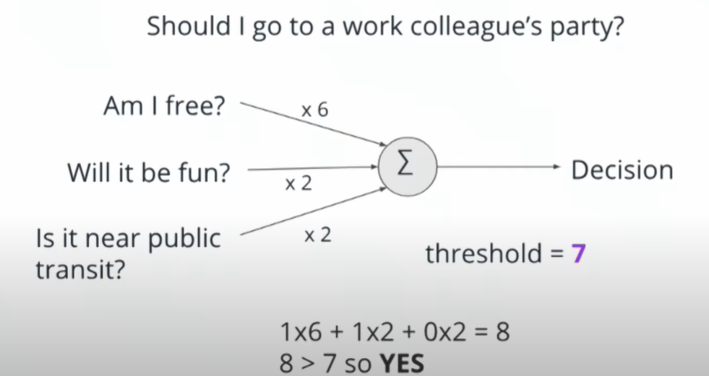

It is to note that it is vital that you and your team know all the important decisions making factors and criteria as it is imperative for what makes a good model. Models are usually not good or bad, just reflective of the inputs and decision making criteria that you give them.

Usually, the decision above is one neuron from a collection of neurons. In this case, it uses that decision as input for another decision. This could also be called as a deep neural network, where each layer makes decisions based on the decisions made in the prior layer. It is an artificial neural network with multiple layers between the input and the output layers. It can be dozens or hundreds, even thousands of layers between the input and the output.

### Application of neural networks today

Image recognition would be one common uses of this. This is where it could recognize an input of a handwritten number from an image where it utilizes multiple pixels in a grayscale where each pixel has a value of between 0 and 255 and you need to understand the order of where those pixels are.

The example of this could be shown below.



The value given in the image above would have 784 pixels and these are important for what comes next where a deep neural networks are utilized to recognize the image above this is as shown below:

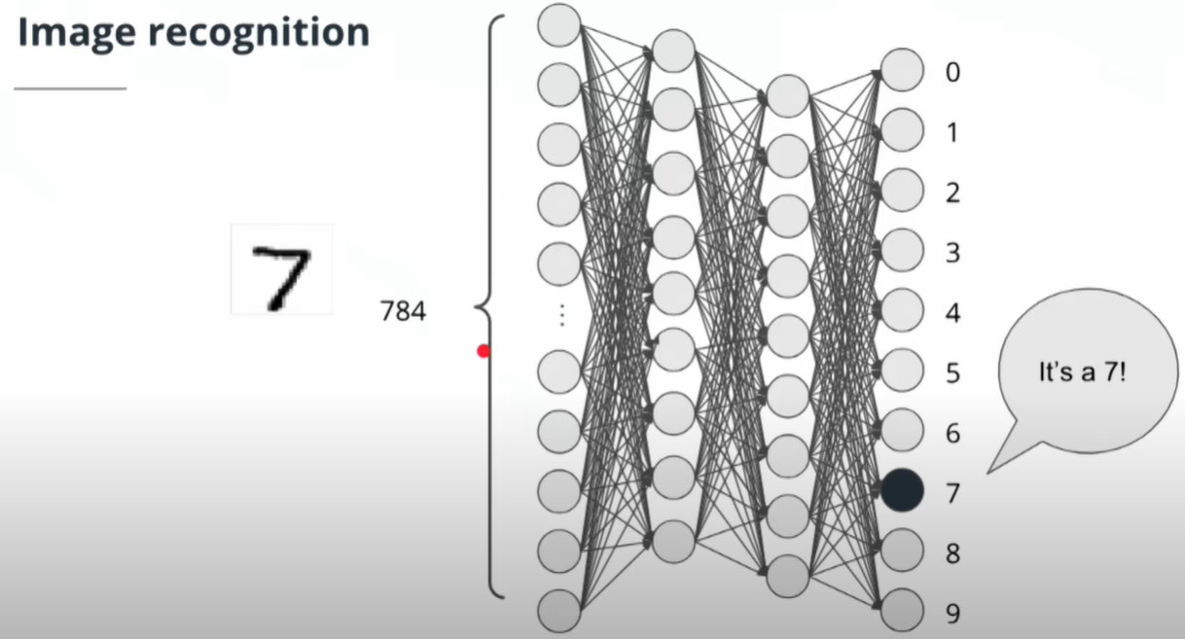

This would then recognize that the image would then be a 7. There neural networks are trained by a large amount of paired input and output values, in this case, handwritten numbers are used. One of the usual cases you can find this is in postal services, where AI is trained by lots of handwritten data and the output is inspected. This can be shown in the image below.

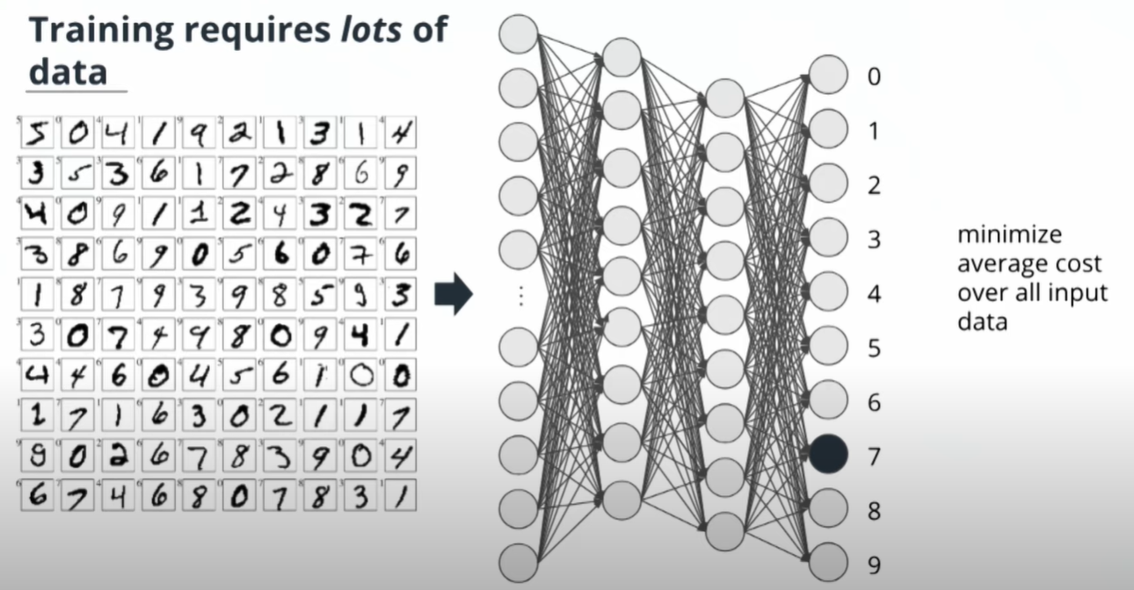

### Current State of AI

In this day and age AI can do the following tasks rather well:

* Specific, narrow tasks
* Learning from large volumes of unstructured data

Also known as first generation AI applications, these are referred to as Artificial Narrow Intelligence. These systems are all over the place in our daily lives. Its what Facebook uses to recognize our faces from images to tag users. Siri to recognize your voice and act accordingly. These tasks are usually narrow and discreet. There are certain tasks that AI can perform better than humans and these are usually games but these again are limited to narrow and specific tasks.

Similarly to humans, AI can be really good at:

* Optical character recognition
* Classification of images
* Handwriting recognition
* Facial Recognition

However, there are things AI is rather bad at and that is doing anything that is outside of what it is trained to do. It is known that AI is quite bad at doing more complex tasks for now. These tasks can be listed as follows:

* Captions & visual descriptions of imagery
* Various robotic tasks(Stable bipedal locomotion)
* General speech recognition
* Complex logical reasoning
* Tasks that are difficult without contextual knowledge
  + Translation
  + Explainability

What can AI do?

“We are at the brink of being able to take an AI, [have it] look over our shoulders, and then [it will] make us maybe 10 or 50 times as effective at these repetitive things” – Sebastian Thrun

### Outro

AI is an umbrella term that describes many different computer science techniques. All of them require data in order to learn information. AI has applications in every industry and is already being deployed to bring down costs and drive efficiency all over the place. The current state of AI is very narrow in its application and has a long way to go before we get into science fiction movies.

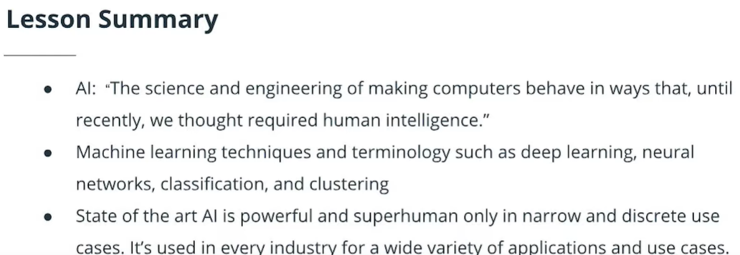

Quiz :

Currently, which of the statements are true:

1. AI can recognise handwriting really well.
2. AI can recognize words spoken in accents.
3. AI can visually describe an image
4. AI can perform multiple robotic tasks at once.

Answer: A

References:

https://www.investopedia.com/terms/n/neuralnetwork.asp

# MODULE 2 : LESSON 3

# USING AI AND MACHINE LEARNING IN BUSINESS

## OVERVIEW

Build products that use machine learning technology at scale

Applications of AI

* Face Recognition
* Retail Inventory Management
* E-Commerce search relevance
* Customer support automation
* Data categorization/classification
* Agricultural automation
* Manufacturing efficiency and quality control
* Optical Character Recognition (OCR)
* Autonomous vehicles
* Sentiment analysis of social media posts/mentions

## AI APPROACH

**Typical Machine learning pipeline**

Model Selection

Use an approach that realizes business value in the beginning of a problem

**STEP 1 - Business Problem, Definition, value, stakeholders, priority, investment**

* This is hardest part
* Define it properly
* Who are the stakeholders?
* What level of investment are stakeholder willing to make to solve the business problem?

**STEP 2 – Data – Availability, provenance, security, coverage, cleaning, augmentation, annotation, refreshing, pipeline development**

* Is right data available?
* What is the provenance (origin) of the data?
* Any security issues?
* What is coverage of dataset?
* Does it need to be cleaned, augmented or annotated?
* What is the strategy for refreshing and pipeline development for data over time?

**STEP 3 – Model Building – Feature extraction, hyperparameters, tuning, selection, benchmarking**

* Build model with appropriate accuracy
* Feature extraction, hyperparameters, fine tuning

**STEP 4- Deploy & Measure – Business value, measurement, A/B testing, versioning, business process integration**

* Many companies get stalled in this step.
* There should be a clear path to deploy the model.
* Setting up ways to A/B test and versioning.
* Integrate the model seamlessly into the business process.

**STEP 5 – Active Learning & Tuning – Bias mitigation, ground truth & success, monitoring, version control**

* Actively learn in production environment
* Refreshing the ground truth
* Mitigate bias
* Monitor and version control
* Rinse and repeat the steps

## BUSINESS NEEDS

1. **Business needs drive the data not the other way round**. Eg: One always plans and packs based on the destination. If going to cold place then pack sweaters, jackets, snow glasses. If going to beach then one generally packs swimsuit, flipflops etc. One does pack first and then decide the destination.
2. Starting with data instead of business need is like packing wrong suitcase without knowing where one is going and for how long.
3. Production systems actively learn from humans to improve performance.
4. Active learning - model can learn from data that is labeled by human annotators and experts.
5. When a model does not know the answer to a specific query or how it might respond to a certain input, you should gather more data from human annotators and re-train your model to increase its knowledge base and increase the confidence of your model.

## THE BUSINESS CASE

### Making a Business Case

Example case provided of Adobe where the task is to find a stock photo for collateral which is likely to drive conversion and sales

If a customer wants a high-resolution picture. It will be difficult for the customer to browse through over 120 million images to select the appropriate image. This is where Adobe can class the images to help customers.

**So, the Business Problem is – Find the right image fast for the customer**

The different steps required by customer to get the correct image is as follows

1. Gather examples of photos with high conversion
2. Gather examples of photos with low conversion
3. Identify visual criteria which are consistent with high converting photos
4. Log on to stock photo database
5. Generate appropriate search query
6. Enter search query
7. Apply filter to narrow results
8. Identify images with corresponding aesthetic qualities
9. Evaluate pricing options
10. Purchase image

QUIZ

Job: find a stock photo for collateral which is likely to drive conversion and sales

1. Gather examples of photos with high conversion
2. Gather examples of photos with low conversion
3. Identify visual criteria which are consistent with high converting photos
4. Log on to stock photo database
5. Generate appropriate search query
6. Enter search query
7. Apply filter to narrow results
8. Identify images with corresponding aesthetic qualities
9. Evaluate pricing options
10. Purchase image

Which sequential steps could use ML computer vision technology to accomplish the task?

1. 1 -3
2. 2-5
3. 5-8
4. 7-10

Answer – (C) 5-8

## Identify AI value

A tool to address business problem is identifying the AI value for each activity. Identify whether the tasks can be done by human or AI.

The tool It can help stack, rank and prioritize different opportunities for machine learning. This also helps to identify what data is needed to accomplish a specific task.

QUIZ FOR NOTES

The steps: definition, value, stakeholders, priority & investment corresponds to which of the following stages of AI approach

1. Data
2. Business Case
3. Deploy & Measure
4. Active Learning & Tuning

**Answer – B**

## Project Statement

Summary:

In order to bring value to your AI Project, you need to identity the following points:

* Problem Statement
* How does AI add value
* What is the data needed
* What is the project scope
* How to measure the success of the project

## Breaking it All Down

In this video, some use cases is given to sort out all the points that were mentioned in the previous section.

See video: <https://youtu.be/0ew7NYl7z4Y>

## Metrics

An effective metrics has the following properties

* Easily measurable
* Directly correlated to business performance
* Predictive of future business outcomes
* Isolated to factors controlled by the group it’s measuring
* Comparable to competitors’ metrics

Generally when we want to apply AI into our project, we would usually build and train an end to end deep learning model to recognize patterns in a large dataset. We’ll then look at metrics that define the success of the trained model and parameters that affect how it trains.

When a model does not know the answer to a specific query or how it might respond to a certain input, you should gather more data from human annotators and re-train your model to increase its knowledge base and increase the confidence of your model.

## Metrics Example: LinkedIn

In this example, we’ll look at how metrics can be used in real world application by LinkedIn.

See video: <https://youtu.be/L_euYcomYxE>

## Need for an AI

Not are projects are well suited for AI. Generally you would use these following question to decide whether to include AI into your project or not. (Note: keywords are **bolded**)

* Do you have an **impactful business problem** that warrants solving?
* Can you **quantify the data** of the business value clearly and simply?
* Does the problem have a **large volume of associated data**?
* Does the **quality of the dataset** you have is complete and matches your use case?

QUIZ

**Question** - What is the correct steps would you work to gauge the effectiveness of a machine learning model?

I – You make decision and apply necessary changes from the obtained metrics.

II – You use measures such as the F1 score, the accuracy, and the confusion matrix.

III – You implement a choice selection of performance metrics.

IV – You would split the dataset into training and test sets, or perhaps use cross-validation techniques to further segment the dataset into composite sets of training and test sets within the data.

1. I, II, III, IV
2. IV, III, II, I
3. I, III, II, IV
4. IV, II, III, I

**Answer - B**

## Additional Notes

References:

1. <https://www.slideshare.net/dmc500hats/startup-metrics-for-pirates-long-version/5-Customer_Lifecycle_Conversion_Behavior_Websitecom>

## Things Need to Be Remembered

Start with Business Value

Get real with the data

Learning is key to value

## Key roles

1. Product Owner
   1. Business case owner
   2. Bridges from stakeholder to team
   3. Own maximization of product value
   4. Ensure that the team build the right product
2. Designer
   1. Owns human-computer interaction design
   2. Visual design, information architecture, interaction design
3. Software Engineer
   1. Build product infrastructure
   2. Problem solver in software development
   3. Frontend / backend
4. Data engineer
   1. Builds data infrastructure
   2. Gets models into production
   3. Ensure entire pipeline can support rapid development and iteration after launch
   4. Model management
5. Data scientist
   1. Builds & select models
   2. Guides the team on the state-of-the-art technology
   3. Structures the problem to achieve the business metrics
   4. Uses data to answer business questions
6. Quality assurance
   1. Owns quality assurance of the product
   2. Ensures product release is ready
   3. Scalability testing
   4. Functional testing
7. Development and operations (DevOps)
   1. Ensure infrastructure reliability
   2. Manage scalability and performance
   3. Mitigate security risks
   4. Ensures development and ML team can work efficiently

## Project management

* How much time should this take?

Bias mitigation, ground truth & success monitoring, version control

Business value measurement, AB testing, versioning, business process integration

Feature extraction, hyperparameters, tuning, selection, benchmarking

Availability, provenance, security, coverage, cleaning, augmentation, annotation, refreshing, pipeline development

Definition, value, stakeholders, priority, investment

1. Business Problem

2. Data

3. Model Building

4. Deploy and Measure

5. Active Learning and Tuning

* Executing an ML project using **SCRUM** methodology

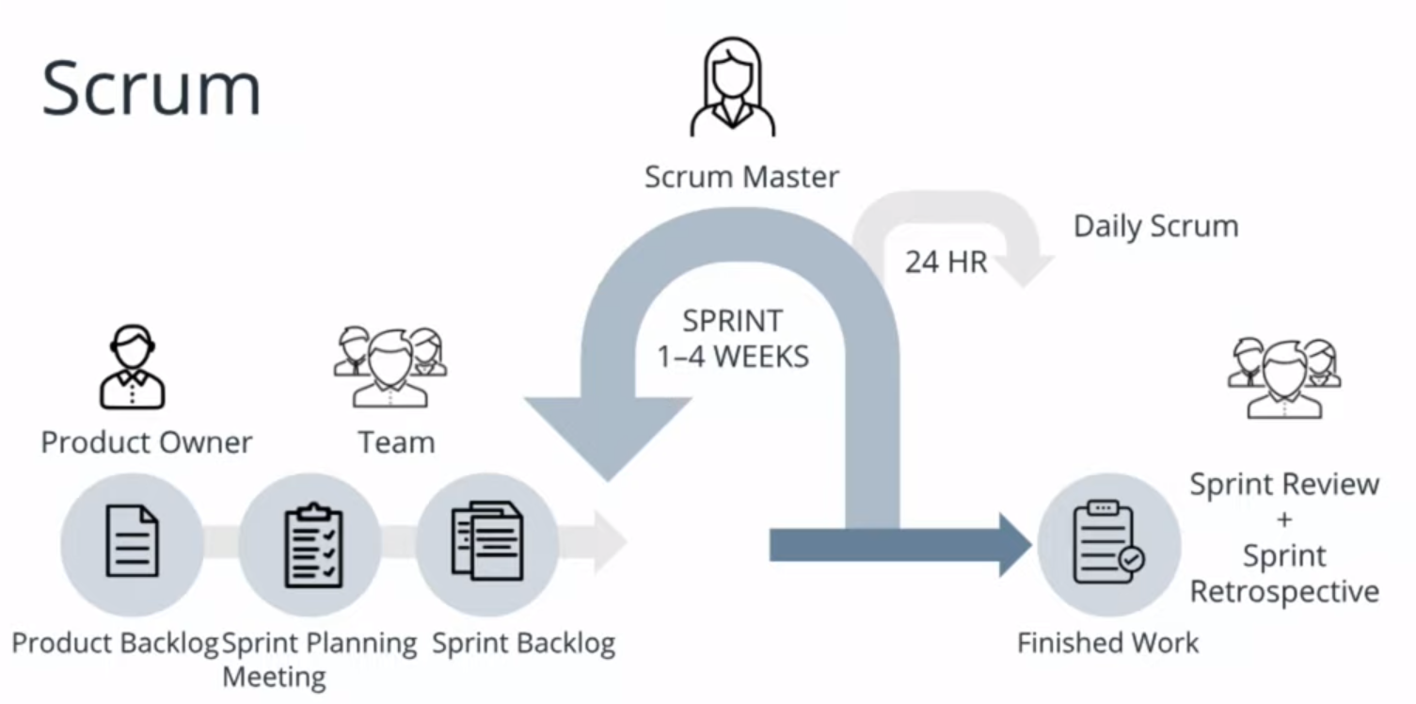

Quiz :  
Which methodology is recommended for Machine Learning project

1. Waterfall
2. Scrum
3. Kanban

Answer : B

# Module 3 - Lesson 1

# Creating a Dataset

## **Answering Questions With Data**

Video: <https://youtu.be/z7A44YnJqCw>

Example used: Improve search results

Data is needed to:

- Return relevant results, OR

- Return results which are tailored to individual preferences

Building a dataset:

- Does the dataset fit the problem?

- Is the dataset complete and contains enough information to represent all real-world cases?

- How to annotate a dataset and ensure data quality and user experience over time

Quiz

Which of the following is NOT a requirement for building a dataset?

1. Dataset should be as complete as possible.
2. Dataset must contain enough information to represent all real-world cases.
3. Dataset must be already annotated with labels of interest.

Answer: C

## As Good As the Data

Video: <https://youtu.be/LDXAmUJN-x4>

How a model performs depends heavily on the training data

Considerations:

- Do you have enough data?

Machine learning (ML) algorithms need many different examples of different types of data to be able to distinguish between different classes and find patterns.

Example:

Movie reviews: To distinguish between positive and negative reviews, a lot of review data is required to gather the specific words/phrases for review categorisation.

Few data points will not provide enough information, resulting in inaccuracy and bias in model.

More data gives the ML algorithm more context and information to learn from, hence able to generalise better when faced with new user data.

|  |
| --- |
| Also be mindful of garbage in, garbage out (GIGO), which means flawed, or nonsense input data produces nonsense output or 'garbage'.  Source: [https://en.wikipedia.org/wiki/Garbage_in,_garbage_out](https://en.wikipedia.org/wiki/Garbage_in,_garbage_out%20) |

A deep learning (DL) algorithm will require a larger data size compared to traditional ML algorithms.

DL aka neural networks need to see many data examples before it can distinguish between them and find general patterns.

Sampling bias is introduced when data points are too few or there are uneven data representation in certain categories.

Quiz

What does garbage in, garbage out (GIGO) refer to?

1. Erroneous inputs will lead inevitably to false and misleading outputs.
2. Erroneous inputs will be rejected from being used in the model.
3. Erroneous inputs and outputs will be auto-corrected by the model.

Answer: A

**i. Data Distribution**

Credit card fraud detection:

Thousands of valid examples and very few examples of fraudulent transaction data, hence we need to take steps to account for this data imbalance, else a model may classify all new data as valid.

**ii. Pattern Detection**

For a classifier to distinguish wolves from dogs, if images of wolves are all shown with snowy backgrounds, a model may wrongly link snow with wolves.

To create a more accurate model, more varied data is needed.

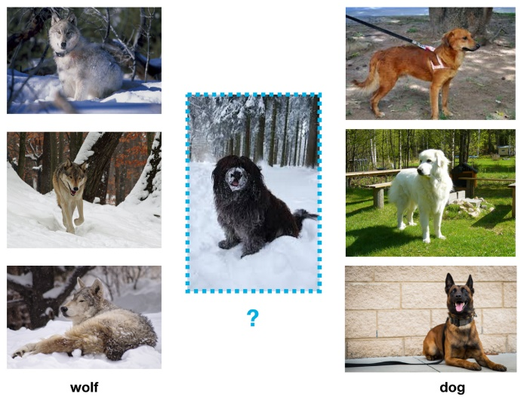

## Data Fit

Video link: <https://youtu.be/veFVZp4SpdU>

i. Use production data to ensure training data matches real-world scenarios.

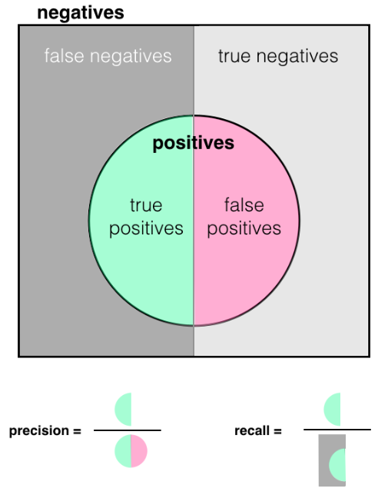ii. Success criteria for a trained model:

* Precision: No. of True Positives (TP) over True Positives plus False Positives (TP + FP)
  + Precision is higher when FP is low
  + “Of those items selected, how many are relevant”
* Recall: No. of True Positives (TP) over True Positives plus False Negatives (TP + FN)
  + Recall is higher when FN is low.
  + “How many relevant items are selected”
* F1 score

Formula: F1 score = 2 × (precision × recall) / (precision + recall)

If criteria are not met, retraining is needed.

A confusion matrix is used for calculating precision, recall and the F1 score.

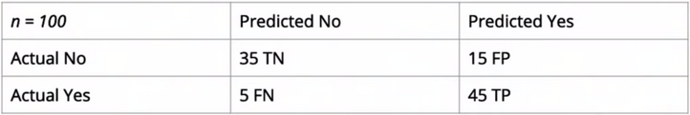

Precision = TP / (TP + FP) = 45 / (45 + 15) = 0.75  
Recall = TP / (TP + FN) = 45 / (45 + 5) = 0.90  
F1 score = 2 × (precision × recall) / (precision + recall) = 2 x (0.75 x 0.90)/(0.75 + 0.90) = 0.82

|  |
| --- |
| Quiz What is the difference between Precision, and Recall?  1. Precision refers to how many relevant items are selected; Recall refers to among the selected items, how many are relevant.  2. Precision refers to sensitivity of the model; Recall refers to specificity of the model.  3. Precision refers to among the selected items, how many are relevant; Recall refers to how many relevant items are selected.  Answer: 3 |

## Data Completeness

Video link: <https://youtu.be/R-d2U20vFqU>

Data collected needs to represent all scenarios that comes up in real world data.  
Consider:  
i. What is the problem, and how does end users benefit?  
ii. What data will help you solve that problem?

* Collect data and observe patterns/relationships in the data
* Identify missing data / potential anomalies

iii. Conduct research and get the best data for your use case.

Quiz  
Which of the following is false?

1. To handle missing data, we can remove observations with missing data, or imputing the missing values based on other observations.
2. Outliers in data should always be removed.
3. We can label missing data as missing (categorical variable) or 0 (for numerical variable).

Answer: B

## Appen's Data Annotation Platform

More info.: <https://www.figure-eight.com/platform/>

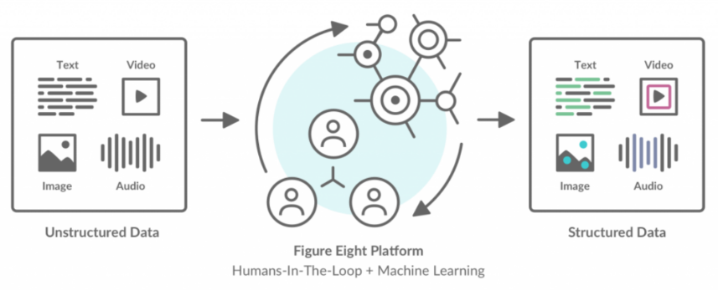

## Case Study: Parking Signs & Figure Eight

Video link: <https://youtu.be/aPHshUsA-FU>

Annotated data is needed to train models. Labelling/annotating data can be in the form of categorising text, outlining objects/images or other labelling requirements.

Figure Eight platform for data annotation:  
- Uploading data  
- Designing an annotation job  
- Creating test questions  
- Monitoring results

## The Platform

Video link: <https://youtu.be/SiEhtRmtDr0>

Fight Eight platform consists of the template library:  
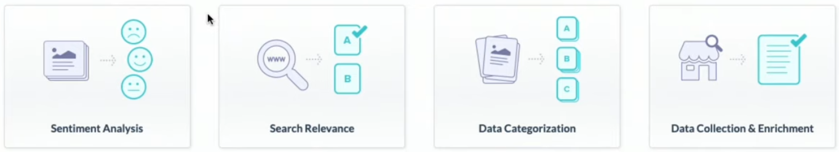

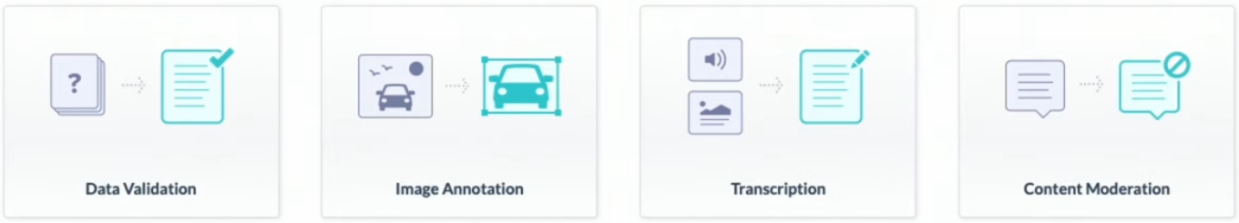

We go to ‘Image Annotation’, and then select the ‘Image Categorisation’ template.

Quiz  
Which of the following are true?

1. Appen’s data annotation platform supports all kinds of raw data (text, video, audio, images).
2. Job templates are useful for building jobs in projects, as most of the steps in the job has been completed.
3. All of the above.

Answer: C

## Job Design

Video link: <https://youtu.be/jDd7sgJL25M>

Steps:   
i. Upload source data  
ii. Design your job using CML*  
iii. Human annotators will choose the appropriate radio button based on the image shown.

*CML (Custom Markup Language) (HTML based language) specific to Figure Eight is used to create the HTML template that will define how human annotators interact with images from the dataset.   
It is easiest to use a template CML and then modify it for a specific use case.

Quiz  
Which of the following about CML is false?

1. CML supports Python, R and Julia.
2. CML is derived from HTML.
3. CML was customised by Figure Eight to be used for creating HTML templates.

Answer: A

## [Instructions & Example](https://youtu.be/uI2XoYjwxfs)

The instructor briefly provides guideline for Appen Data Annotation service. User should include:

1. Overview of the task (example: Identifying sign board in the images)
2. Steps required to complete the job
3. Rules & tips (example: sign board of street cleaning, no parking, tow away in San Francisco). Try to be as specific as possible with the rules.

Contributor should include sample images of actual data set which covers different possible scenarios: (1) sign boards that are easily identifiable, (2) sign boards that are not easily identifiable and (3) no sign board at all.

## [Test Questions](https://youtu.be/yWNOkjGQj1M)

After completing the “Design” job, move on to “Quality” stage to create test question. Appen comes with this feature of creating question(s) for each image allows contributor to provide reasons of failed cases. This should help to improve data annotation quality. Algorithm in Appen platform will learn and improve as it goes through more samples (which include reason of failed cases).

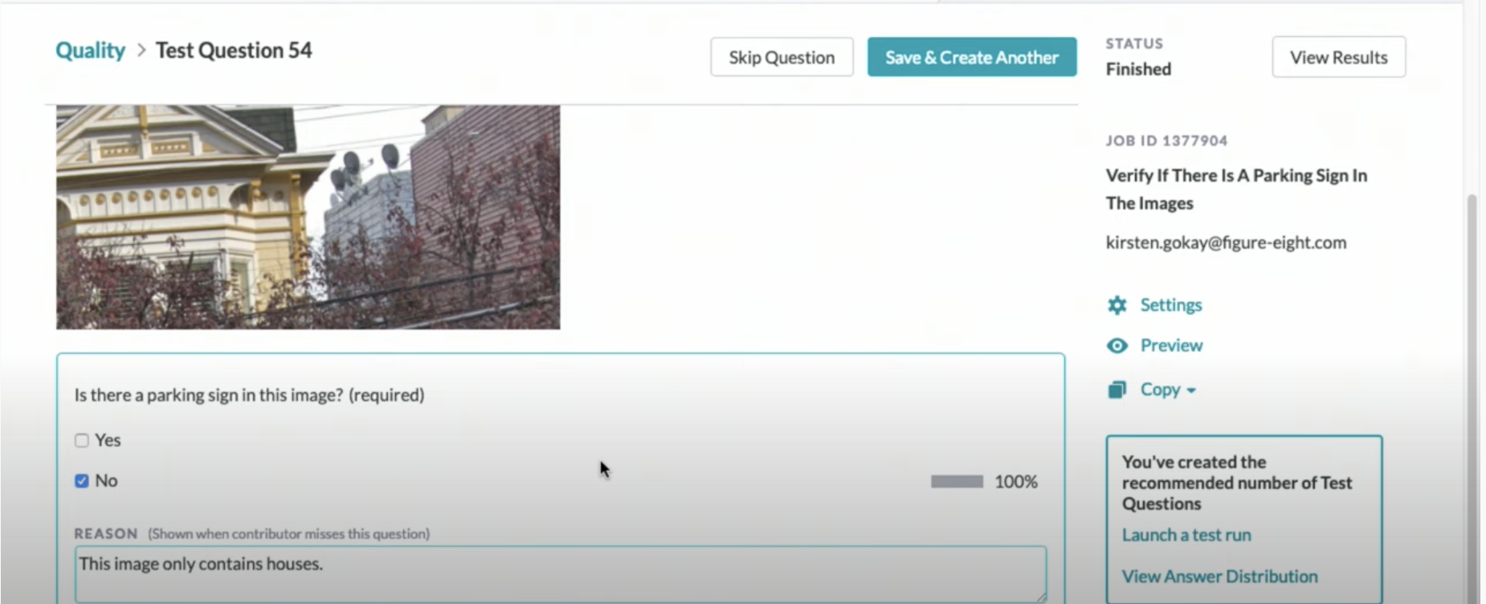

Test Question

Before launching the job, contributor need to check the job quality of “identifying sign board in San Franciso”. Contributor is advised to review the distribution of answer (Yes/No of sign board in image) and ensure to achieve balance between answer of “Yes” & “No” to avoid biasing distribution.

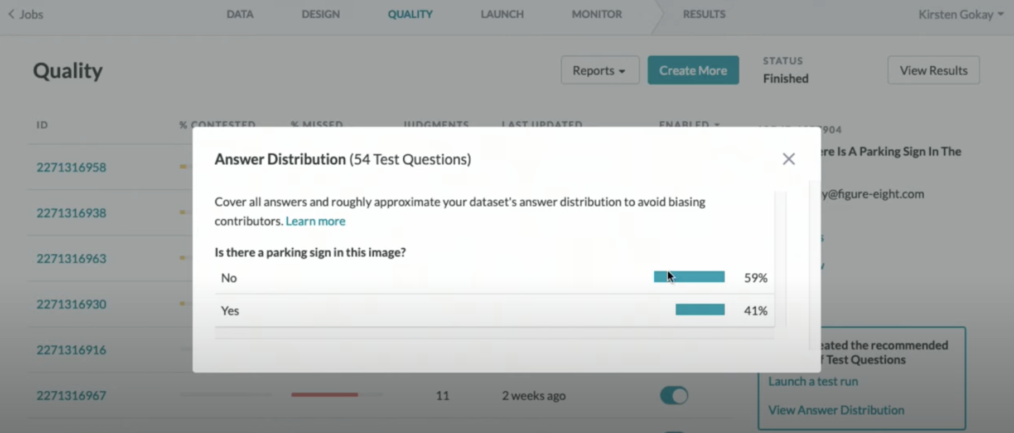

Distribution of “Yes / No”

## [Auditing Results](https://youtu.be/AhYSVn3WqgU)

Review result and quality of your job.User can download “Result” report to understand where the image identification goes wrong and possibly go back to job design to improve the test questions.

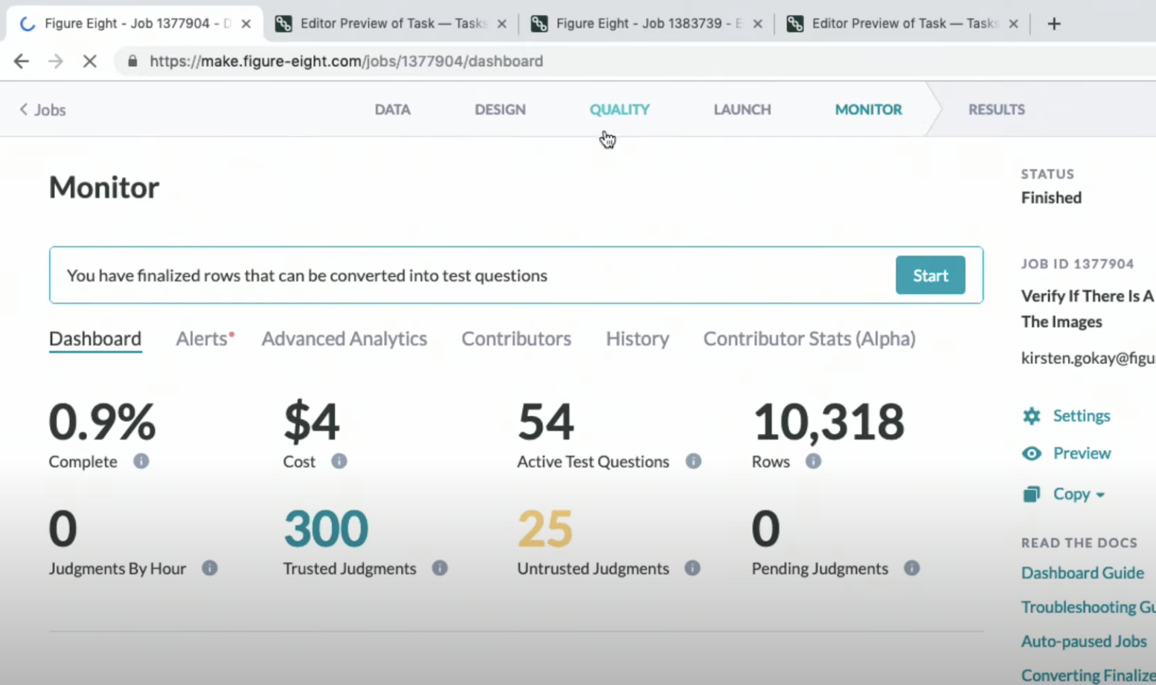

Quality Monitoring

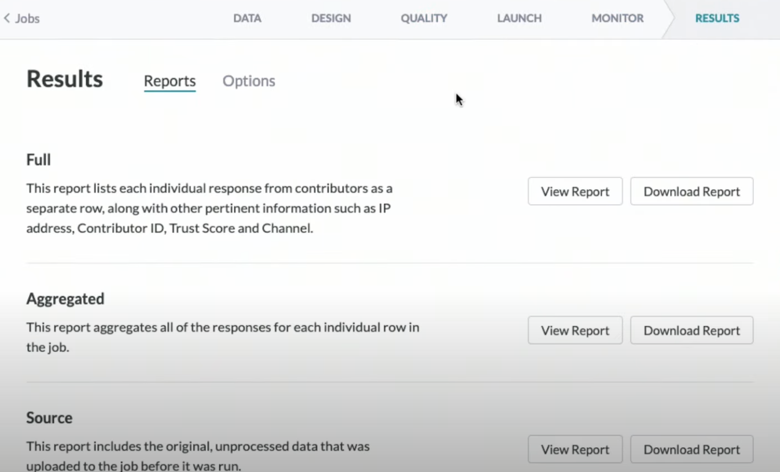

Result Page

## Planning for Failure

There are endless possibilities/scenarios to train an AI model (imagine countless of sign board in San Francisco and places without sign board) and this may lead to incorrect identification of sign board. To handle such issue, we can opt for “least negative impact” model training. In short, if there is ambiguity in the scenario, choose the “safer” approach (i.e. for an image consists of a broken sign board, “No” is better choice).

## Planning for Longevity

Real life data continuously change, so we need to account for the change with different AI model.

1. Static model: for data that is hardly updated
2. Dynamic mode: suitable for ever-evolving data. Continuously train on new data and AI model will learn on new data. Contributor need to change annotation job, update rules/definition and include more relevant samples.

quiz:

A “Static” AI model is suitable to train real-time data (i.e. data updated frequently)….Yes / No?

# Module 4: Lesson 1

# Build A Model

## Overview of Modeling

Modeling and machine learning consists of constructing the core components that will serve as the framework for a machine learning model. neural networks are some of the most common models used in ml. A neural network is a series of layers each of which contains different nodes which will perform various calculations. The structure of these layers as well as how they're connected is what is known as the architecture of the network. There is a process known as neural architecture search that further optimizes the creation of a neural network.

## Activation Functions

Neural networks can be used to make decisions on whether or not to transmit signals to other layers of the network. Activation functions are functions that we can use as a decision boundary to inform us when to transmit a signal to subsequent layers in the network. These functions allow us to adjust the likelihood of a certain decision based on inputs, such as a weight for each input, and a decision threshold. To illustrate this basic threshold, a basic threshold is in essence a step function. This means that until we pass our threshold we do not pass a signal, i.e we have a zero or no decision, and once we reached the threshold, we immediately jumped to one.

When executing a complex task such as transcribing a document, we want to allow for some uncertainty. This means that we need a better decision boundary that will give us room for error. Using a sigmoid function we receive an output with a range of zero to one. And this provides a continuous decision boundary where each node in the network acts as a sort of knob.

In machine learning, we actually have many different types of nodes, that each of which has their own pros and cons, and are used for various applications. Given an input, you will provide the machine with the desired output, via your training labels in the training data. The machine will then incrementally update those weight parameters, to best optimize the model for all input output pairs. This is how the model learns from the training Data, and why the training Data is absolutely critical to the model creation process. The actual method for updating the weights is called Back Propagation, and it is an algorithm used to automatically update those weights on the inputs in each node. It is commonly used in what's commonly known as a Multi-layer Perceptron which is a specific type of neural network. for various

## Modeling, Key Points

Neural networks are the basis for many of the ML that we see today. This networks consist of nodes which are connected together by inputs and outputs. The input weights of each node are tuned and eventually determine the behaviour of the data flowing through the network. There are various types of nodes and networks focusing in particular applications.

## Training Data

Training Data is the currency of machine learning and is the basis of learning component in ML

Training Data is like teaching a young child that has never seen a car what a car is

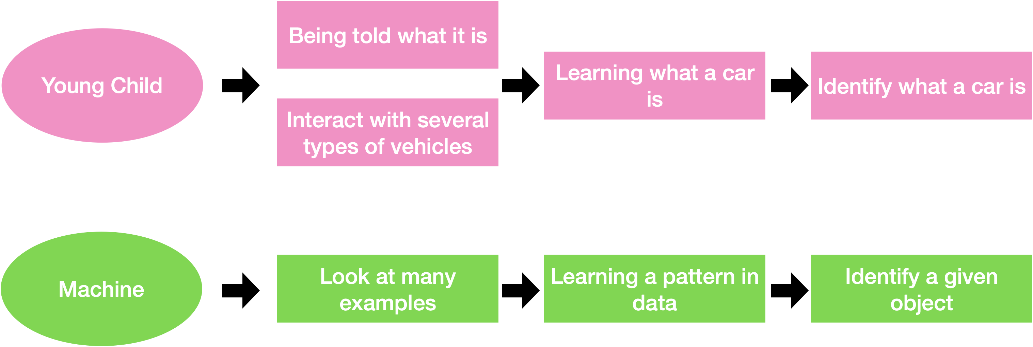

Data in ML

* Data defines model behavior and performance
* Model parameters are updated based on training data
* A model will not learn if it’s not in the data
* Bad data = bad model

## A pet model

Imagine a model that determines the type of pet in the image

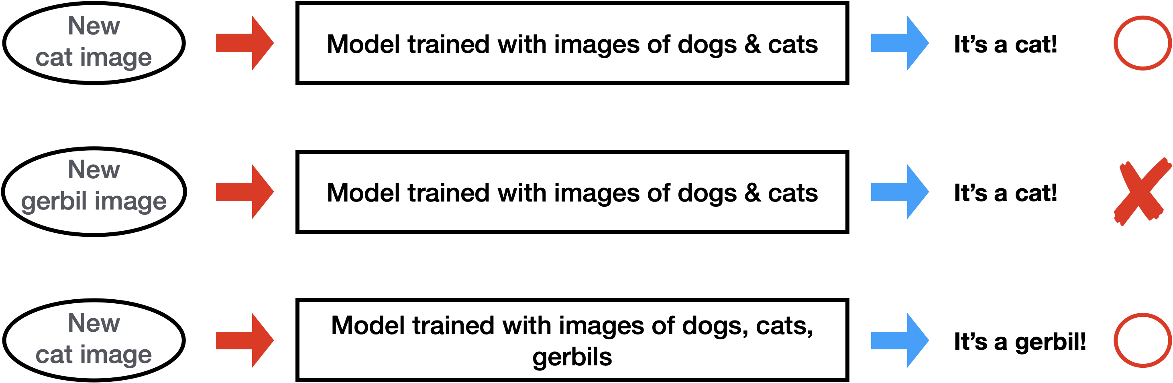

If the model is not given a particular type of data, it will never be able to infer on other types of that data.

Only after being trained on a given type or class of data, will the model begin to make predictions of that type

## Training Data is Key

When training a model, you must train it with all types of data that the model is likely to encounter in the future in order to build a robust model.

* Models will only learn about data that they are trained with
* Ensure that the data used to train a model reflects real-world data
* Use a diverse set of data to build a robust model
  + If model only trained with images of dogs in the snow, very unlikely to identify a dog pictured in a field of grass

### Example of training with the wrong data

Want to train a model to detect shoes

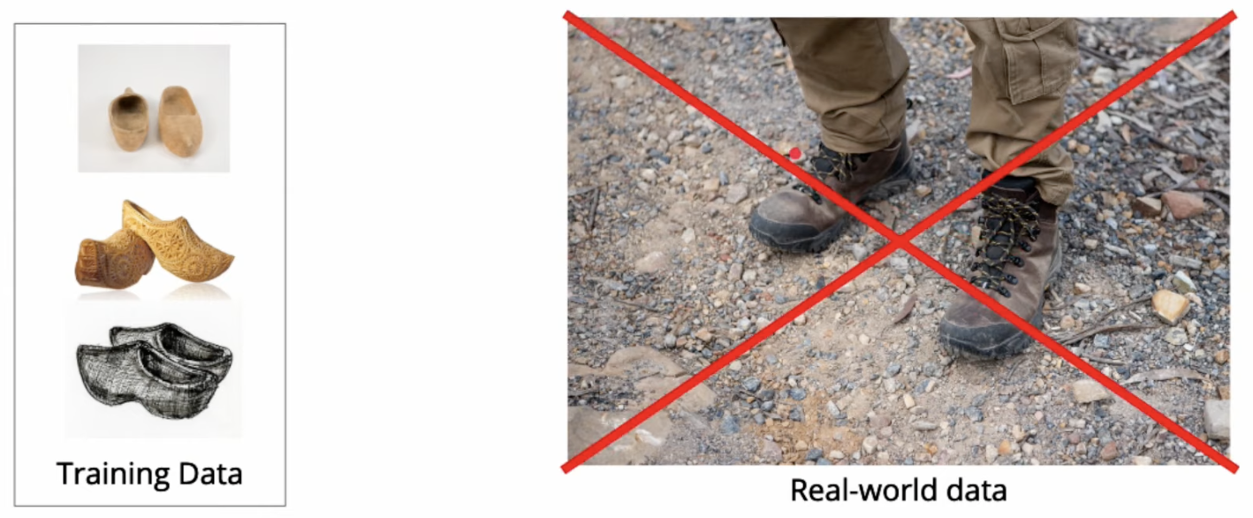

* Training data doesn’t represent all the types of shoes that we see in real-life

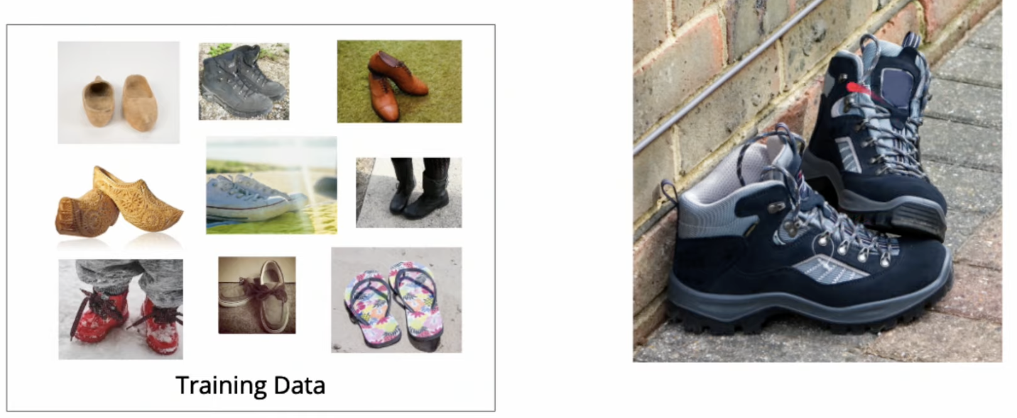

* Now model will be able to identify the type of shoes

The right data… Diversify your data to understand all the potential scenarios

* Data that encompasses all likely scenarios
* Photos from the real world (not just a studio)
* Audio collected with background noise
* Text of various writing styles
* Equal amounts of the different types of data

### Common Issues with training data

1. Distribution of training data

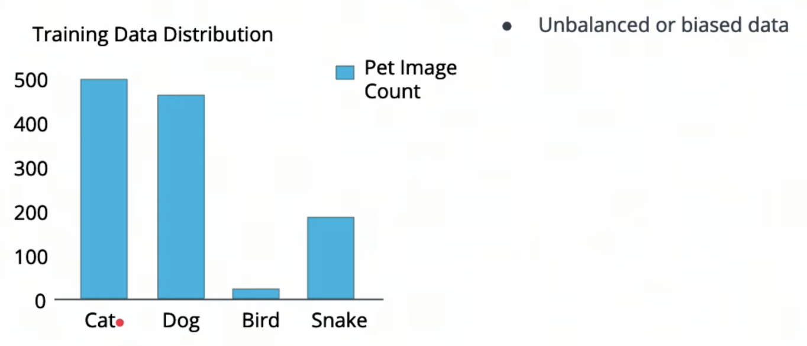

Model will learn significantly more about cats and dogs than other classes and will tend to bias towards those classes

To prevent this, we can

* Collect more training data for the classes that are lacking
* Reduce the amount of training data for those that have too much

More training data will often lead to a better model, balancing the data is as important if not more to produce an unbiased model.

1. Training Examples are different than the real-world examples

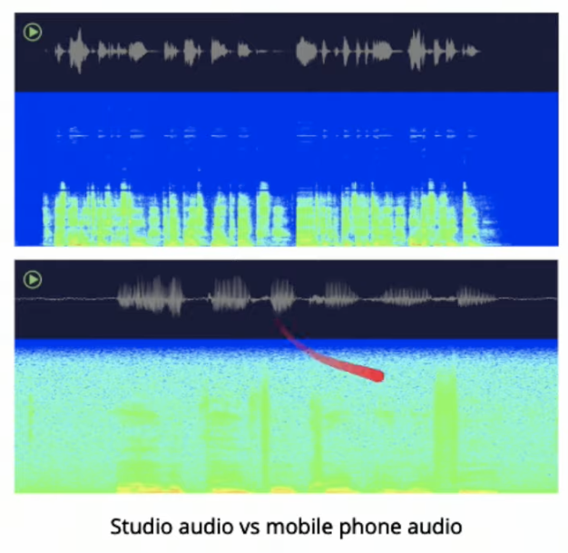

Audio collected from mobile device has a great deal of noise as the cases real life situations.

If we were to train the model only on studio audio, our model would fail miserably at detecting audio collected from mobile devices.

Example where we want to be aware of what the real-world data will look like, so we can collect the appropriate data

1. Issue of mislabeled data

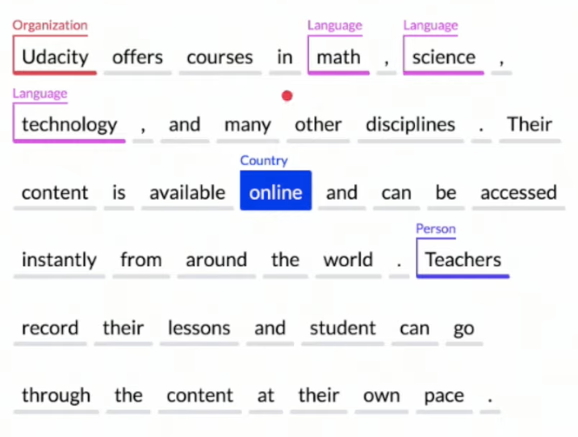

Parsing entities out of text, may be unclear where any particular entities should be classified.

Need to ensure that the labels that are returned are accurately classified as expected.

1. Insufficient data

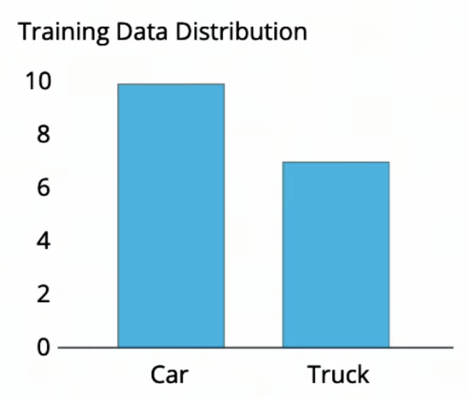

The amount of data required will vary widely based on a number of factors, including the datatype, complexity of the data.

No clear-cut rule as to how much data will be needed!

Generally, we want to start with a few 100 examples of each target class and then scale up the amount of training data until we reach a desired accuracy.

## Training Data Summary

* Training data is key to building robust AI
* Training data will make or break a machine learning model.
* Ensure there is a variety of data and that the data reflects real world scenarios
* Unbalanced data will cause a model to skew towards a particular outcome
* Mislabeled, or dirty, data will significantly impact model performance

Quiz:

Q. Assume that you want to make a face-mask detector for the grocery store, which detects a person not wearing a face mask in the store. What is the best data would you need to train this model?

1. 100 images of people shopping in department store
2. 5-hour CCTV video of the grocery store recorded when people didn’t wear face masks
3. 10-hour CCTV video of the grocery store recorded when everyone wore face masks
4. 5-hour CCTV video of the grocery store recorded when people didn’t wear face masks and 5-hour CCTV video of the grocery store recorded when everyone wore face masks

Answer: D. Detector should be trained with 2 classes, wearing mask or not. There need to be a sufficient amount of data for both classes.

## Model Evaluation

**Formula**

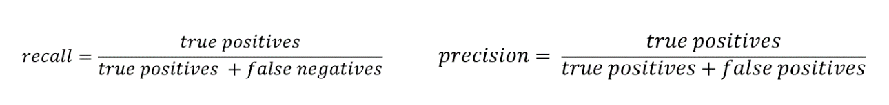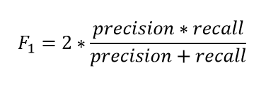

What is the F1 score?



A 0.82

B 0.30

C 0.46

D 0.90

**Answer : A**

**Precision** : 45 / (45 + 15 ) = **0.75**

**Recall** : 45/ (45 +5 ) = **0.9**

**F1 SCORE :**

2* (0.75 * 0.9) / (0.75 + 0.9)

2* 0.675 / 1.65

2* 0. 409

= 0.82

## Transfer Learning

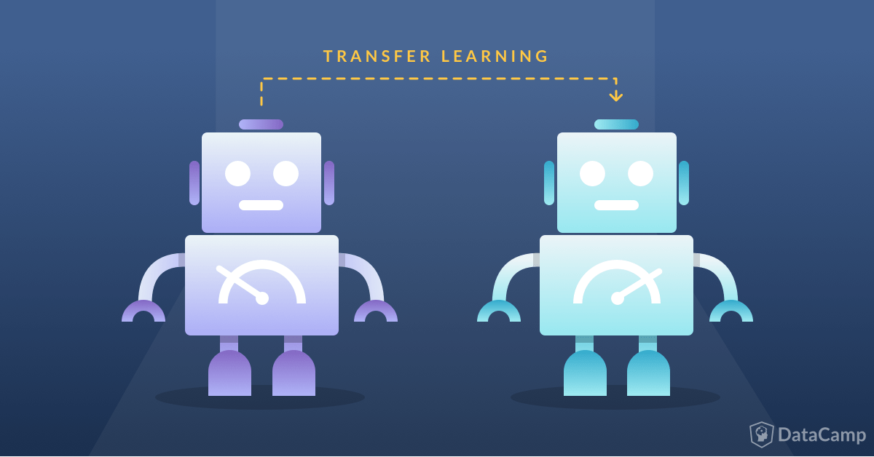

A visual representation of transfer learning.

Imagine you’ve just started a company, and you want to implement AI image recognition to help people differentiate between the different types of birds in the wild. This task is very monumental, especially for a company with little to no resources and money. It seems the only way to get around this is to just blatantly copy someone else’s model, but that’ll make it difficult for you to optimize the accuracy to your specific problem.

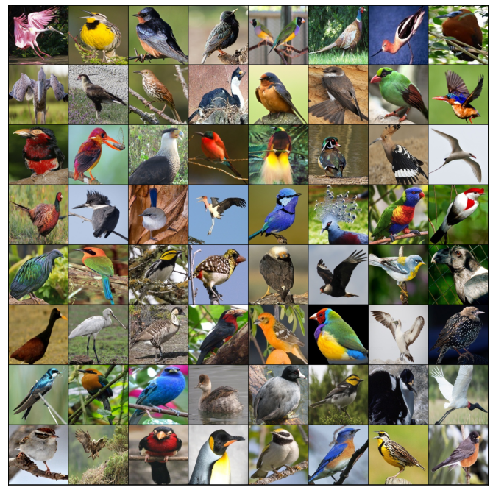

                Examples of images that can be passed into the secondary model.

**Transfer learning**is a machine learning method where a model that has already been developed is reused as the starting point for another model. This fits the problem we had above perfectly! You can take a high-accuracy image classification model that is already trained, and you can apply it to your bird classification problem!

Instead of training the model from scratch, transfer learning allows you to start at a pretty well-trained model and optimize it for your problem. Think about your original predicament as studying for a test without a study guide, and transfer learning as being that study guide for you. Although it doesn’t solve your problem outright, it definitely makes it easier for you to find the solution to your problem.

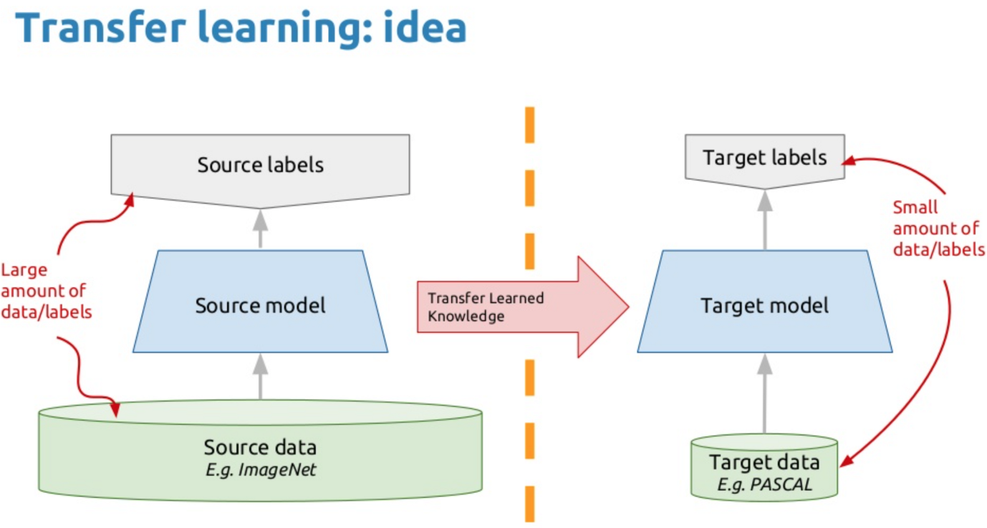

Basic representation of a transfer learning model.

**There are three steps to using transfer learning:**

* **Choose source model**. Choose a source model from a list of already trained models online. This can be found from a variety of places from past projects you’ve completed to other research institutions that have open-source AI models.
* **Use model**. Integrate your model with your current problem, and use the source model as a starting point for your true goal. You don’t have to use every part of the model, depending on what you’re attempting to do in the ending.
* **Tune model.**The model has to be adapted to fit what you’re attempting to solve. This can include a variety of optimizations and additions, such as choosing a different output layer or making different hidden layers.

**Terminology**

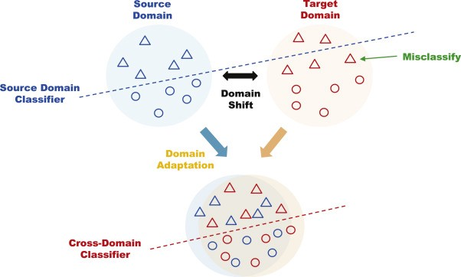

How a cross-domain adaptation transfer learning model works.

Because transfer learning has so many different methods of implementation, there are a variety of terms to keep in mind. Here are some common terms that you will hear:

* **Cross-domain adaptation:** This is when the feature spaces of the source and secondary domains are different. An example of this would be when two documents are written in different languages. This is commonly referred to as cross-lingual adaptation in NLP.
* **Domain adaptation:** This is when, for example, two documents, would discuss different topics, but would still have the same underlying language. This would be used to refer to transfer learning where a large domain shift is needed, but not as large as cross-domain adaptation.
* **Label alteration:** This is when the labels/outputs of the secondary and source model are different.
* **Label unbalance:**This is when the source and target documents are unbalanced with regards to the number of classes. An example of this would be the example in the introduction. Note that label alteration and label unbalance are very similar to one another.

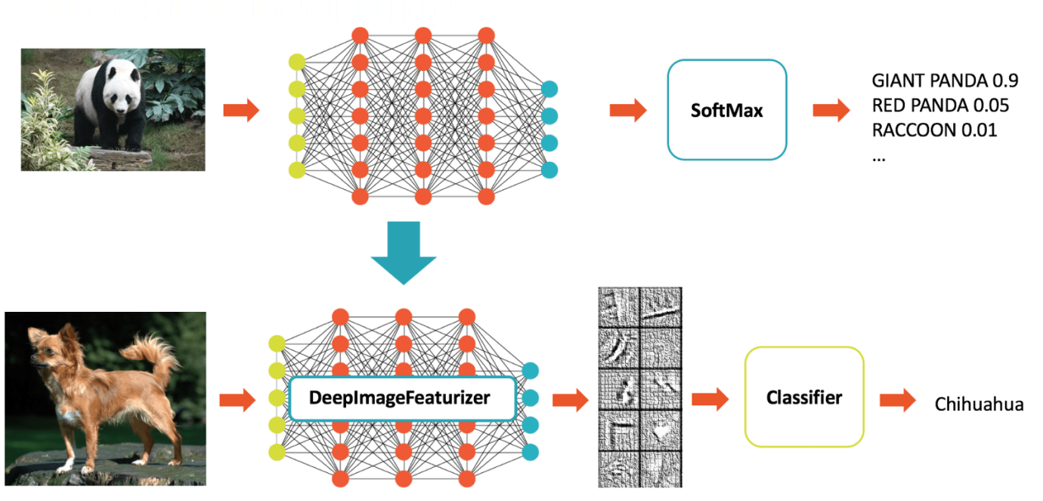

Example of transfer learning for NLP

## Automated Machine Learning

Automated machine learning, also referred to as automated ML or AutoML, is the process of automating the time consuming, iterative tasks of machine learning model development. It allows data scientists, analysts, and developers to build ML models with high scale, efficiency, and productivity all while sustaining model quality. Automated ML in Azure Machine Learning is based on a breakthrough from our Microsoft Research Division.

Traditional machine learning model development is resource-intensive, requiring significant domain knowledge and time to produce and compare dozens of models. With automated machine learning, you'll accelerate the time it takes to get production-ready ML models with great ease and efficiency.

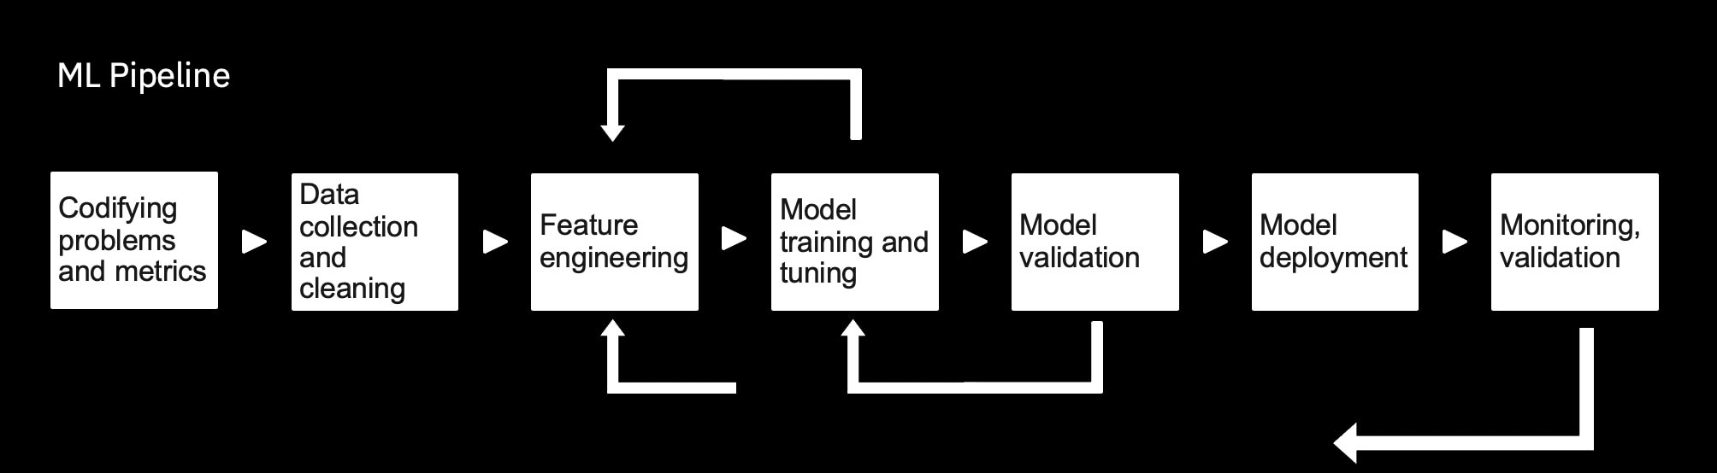

## Automated ML vs Custom Modeling

|  |  |
| --- | --- |
| Automated Machine learning | Custom Modeling |
| +Easy to get started | +Completed customizability |
| +Robust Enterprise support | +Unlimited use cases |
| +Cheap for quick development | +Full control over parameter tuning |
| -Limited use cases | -Expensive to get started |
| -Difficult to extend | -Requires ML expertise |
| -Data is accessible to provider | -Limited means of external support |

## Transfer Learning and Automated Machine Learning Summary

* Transfer learning uses knowledge from previous models
* Pretrained models can be found online for use with transfer learning.
* Automated ML makes it easy to create models.
* For more complex models a custom development may be required.

## Outro

A machine learning models are defined by the architecture and the training data used to train them in order to use machine learning models in production we want to thoroughly evaluate the performance.so we are aware of the models and how it's likely to perform when deployed. In machine learning, there certain tools such as transfer learning and automated ML that we can use as aids to help us build model faster.

# Module 5: Lesson 1

# MEASURING BUSINESS IMPACT AND MITIGATING BIAS

## Introduction to Business Impact

This chapter covers steps required to measure business bias and Scale AI product

Key Topics

* Benefits & Challenges of AI initiatives
* Define and measure success metrics
* A/B testing & Versioning
* Monitor & mitigate bias
* Continuous learning
* Compliance & ethics
* Scale

## Case Studies and Challenges

### AI Benefits

AI’s leading benefits are enhancing products and processes and better decisions

Survey showing the AI benefits for companies.

1. Enhance current products
2. Optimize internal operations
3. Make better decisions – eg: fraud detection
4. Optimize external operations
5. Free workers to be more creative
6. Create new products
7. Capture and apply scarce knowledge
8. Reduce headcount through automation
9. Pursue new markets

### Case Studies

1. **NETFLIX** - Netflix found out improving search results using AI, user frustration and customer churn can be prevented. They manage to save US$1 billion a year in potential lost revenue.
2. **BLUERIVER technology –** Agricultural business where they used see and spray technology thereby saving on pesticides and at the same time targeting only the weeds and not the crops. Their equipment had visual intelligence which used computer visual algorithms to identify plants and only spay weeds. They managed to save 50% reduction in seeds costs and 90% in herbicide costs . They were also environment friendly.
3. **Manufacturing Industries (GE) –** Using AI to predict failure in advance and thus help in savings.

### Challenges of AI Implementation

Companies are however facing challenges when they seek to implement AI

Top challenges are

1. Implementation Challenges
2. Integrating AI into the company’s roles and functions
3. DATA issues (data privacy, accessing and integrating data)
4. COST of AI technologies / solution development
5. Lack of Skills
6. Challenges in measuring and proving business value

## Measuring Success

There is a huge gap between research into AI and delivering tangible business results.

As per Forrester survey only 58 % of businesses have considered AI but only 12% out of those companies put AI into practice.

Defining business goal and success metric is the first steps

1. Business goals – for different industries the goals may differ
2. Revisit success metrics
   1. Customer Experience
   2. Revenue Gain
   3. Customer Engagement
   4. Business process automation
   5. Better & faster decision making

## Outcome vs Output

AI products must be deployed to deliver business outcomes. Focus on outcome and not output. Monitor the output of AI model (accuracy, performance, fairness) and understand the reasoning behind the results.

The table below provides the metrics for business outcome vs model output.

|  |  |
| --- | --- |
| **OUTCOME** | **OUTPUT** |
| Generate Revenue | Accuracy |
| Improve Customer Experience | Execution time |
| Increase user satisfaction | Recall |
| Automate & Save cost | Precision |

## Chatbot Example

Key Success Metrics for chatbot are shown in table below

|  |  |
| --- | --- |
| **Success Metrics** | **Associated Business Metric** |
| Number of Active Users | Conversion Rate |
| Number of bot sessions initiated | Customer Support Savings |
| Average Chat sessions | Increase in Net Promoter Score |
| Average chats handled by bot | Cost per Acquisition |
| Number of new users using bots daily, weekly, monthly | Lift in Engagement |
| Number of Active Users | Customer Retention rate |

After measuring the metrics should be benchmarked against the goal and keep improving and optimizing the machine learning model and user experience.

Some key metrics to collect data and carry out benchmarking against goals.

1. User adoption & retention
2. User engagement
3. Conversion rate
4. Self-service rate
5. User satisfaction

**Net promoter scale** – calculates based on responses to a single question “How likely is that you would recommend our company/product/ service to a friend or colleague?”. The scoring is often based on a 0 -10 scale.

**Cost per acquisition (CPA)** – online advertising pricing modle where the advertiser pays for a specified acquisition eg: sale, click, form or submit

## A/B testing & Versioning

A/B testing helps to make data driven decisions when it comes to evolving the product and improving it.

It is very common to send about 20% of your customers to a new model (v2, a "challenger" model) and 80% to a well-tested model (v1, a "controlled" model). This way, you can get some good experimental data and really see if the v2 of your model does indeed work better; if it does, you can then switch all user traffic (100%) to that new model.

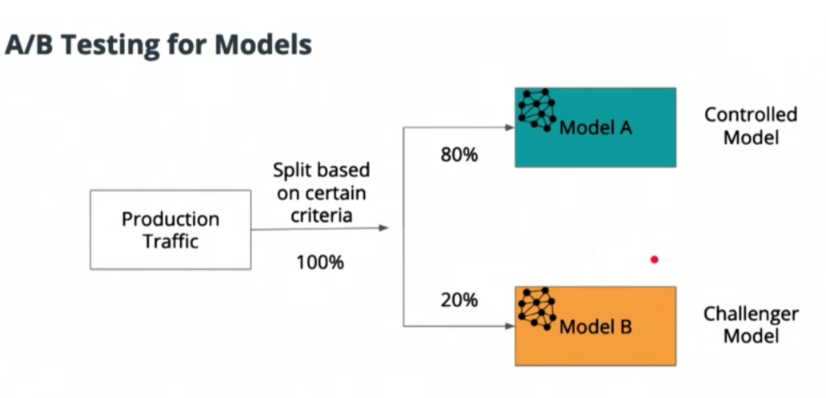

**Avoid a major pitfall of declaring success to soon in A/B testing.**

Designing A/B test for models (best practices)

1. Deciding on performance metric
2. Deciding on test types based on performance metric
3. Choosing a minimum effect size to detect
4. Determining sample size
5. Running the test until sample size is reached
6. Cost benefit analysis (eg: is 10% accuracy gain beneficial for business)
7. Run the test long enough to capture any seasonality effects
8. Control to experiment to avoid novelty effect -initial positive reaction that wears off

## Monitor Bias

Monitoring and mitigating bias should be an ongoing initiative as AI product is launched and scaled.

Bias – AI systems are only as good as the input data. Bad data can contain racial, gender and ideological biases.

Examples of bias

* Some Accents don’t work for voice assistants – Alexa and google assistance are 30% less likely to understand non-American accents
* Facial recognition is more biased towards white, male faces.

Different types of Bias

1. Model Bias – when model itself generates biased outcome
2. Data Bias - when unbalanced selection of source data is used
3. Annotation Bias – introduced by humans annotating and generating the training data

Some of this bias can be mitigated by involving a diverse team of developers and going through rigorous audits to test for quality and use-case coverage.

## Addressing Unwanted Bias

Identify all unwanted bias and come up with remedies based on **target user base and business needs.**

**Handling Unwanted Bias**

1. Awareness – define the decision you are asking the model to solve for. eg: - a model detecting human (does cartoon count, does only a visible hand count.). It’s really important to define properly.
2. Data – collect data from multiple sources. Cover for enough examples and edge cases. Have diversity in data collection and model development.
3. Iteration and Learning is ongoing process. Be transparent, take feedback, be empathetic.

## Continuous Learning

Continuous learning involves a feedback loop between human and machines that eventually tunes the machine learning model.,

The figure below shows the flowchart for continuous learning.

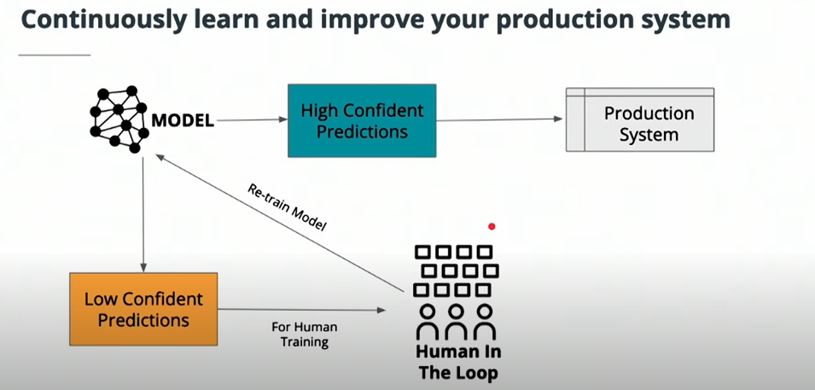

SMART Selection

Instead of processing all unlabeled data use smart selection method. Select the most relevant data that can improve the accuracy of model. Discard harmful data.

Smart selection has 4 key criteria

1. Low confidence – Any data type that model has lower confidence in
2. Uncertainty – Scenarios that model is unable to predict
3. Novelty – any new data that comes up and model has never trained on that
4. Class importance – identify the classes that are important for the model and the data related to those classes are given higher priority

## Spam Filter

Real world example of Spam Filter

1. Filter email with machine learning – first use machine learning to filter email. This has accuracy of about 80%.
2. User corrects mislabeled spams – Users will correct the mislabeled spams.
3. Retrain model with user data – Use the data that users are relabeling
4. Accuracy improves with time – Iterate the whole process to improve model.

## Model Optimization & Staleness

Apart from model accuracy, recall and precision and also important.

Recall – Percentage of total relevant results correctly displayed by model

Precision – Proportion of data points which model says was relevant were actually relevant

Example – for cancer diagnosis a false negative is completely unacceptable (person having cancer is told that they don’t have cancer).hence recall is more important in this case.

However, for you tube recommendation system, precision is more important.

Some models (example fashion industry) are at risk to staleness. So, models must be refreshed over time.

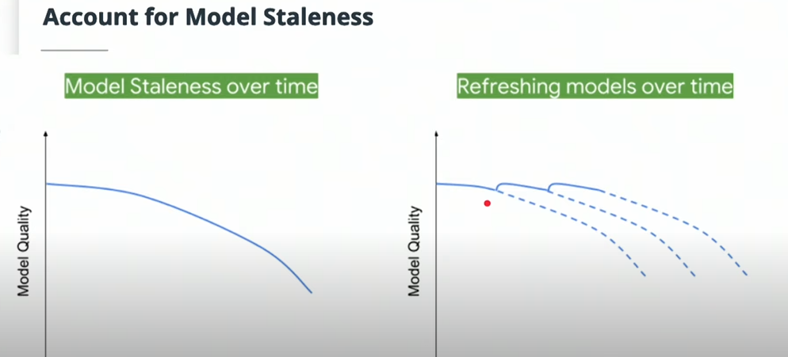

Important points to consider for Model refreshing

* Not all models are at risk – eg: model predicting cats and dogs images.
* Unwanted feedback loops – This can affect model performance.

## Compliance and Ethics

AI is used for different fields like Granting parole, granting credits, autonomous weapons. AI is raising serious questions about compliance and ethics.

41% of voice assistant users have concerns over trust and privacy. Hence building user trust is important factor for AI product managers.

Another example – San Francisco has banned facial recognition technology due to concerns around potential abuse of the system.

## Privacy-First Approach

AI should be built with ethics and compliance.

**The world’s most valuable resource is no longer oil but data (The Economist)**

Some important factors about data

1. Huge amounts of high values business data is involved
2. Balancing features and attributes vs model accuracy/business goals
3. A lot of stakeholders are accessing, enriching and refining the data in AI product lifecycle.

Privacy first approach should be there

1. Data laws and AI coexist with privacy first approach
2. Deeper understanding & governance of data
3. Understand the sensitivity of data
4. Obtain explicit consent and explain to customers how their data will be processes.

The figure below shows the key considerations from privacy point of view.

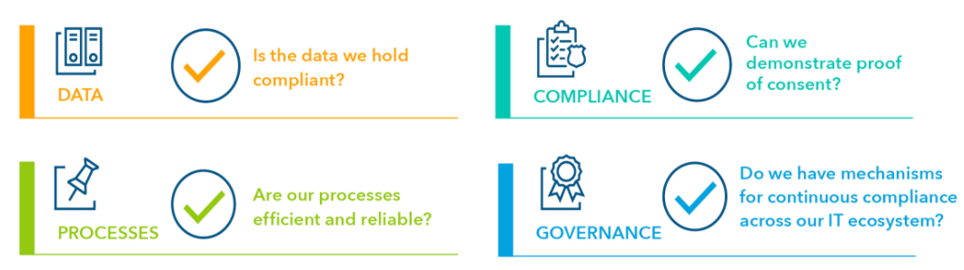

## Scaling a Product

Organize for Scale

1. Machine architecture
2. Organizational Structure

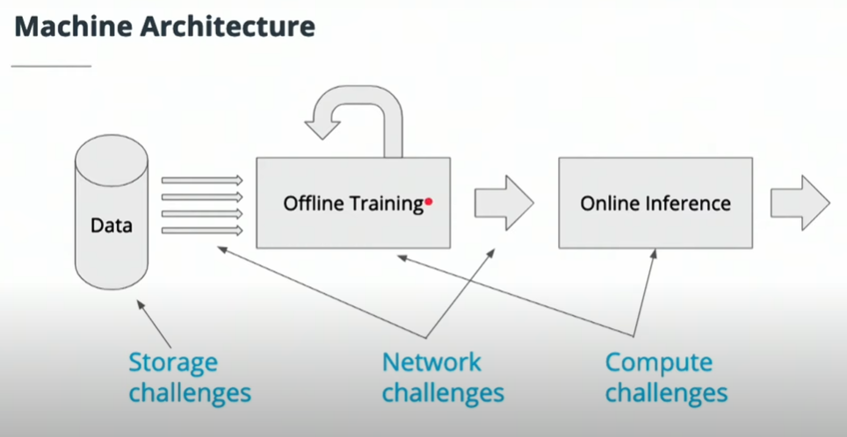

As AI is scales, organization structure becomes quite important. cross functional coordination and planning is required.

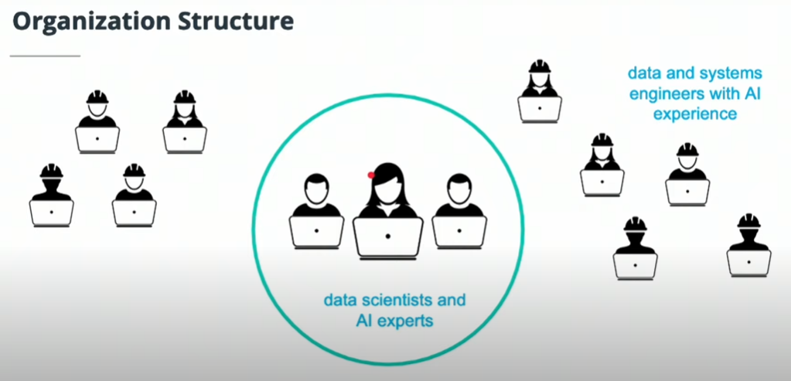

## Summary of Skills

1. AI beings a lot of business benefits
2. Measuring success metric
3. Continuous learning of models
4. Monitoring and mitigating bias
5. Security & data privacy

QUIZ

Which of the following bias is introduced by humans while generating the training data?

1. Model Bias
2. Annotation Bias
3. Data Bias
4. None of the above

**Answer – B**

Which of the following are business outcomes? Select all that apply?

1. Model accuracy
2. Generate Revenue
3. Improve Customer Experience
4. Model execution time

**Answer – B & C**

# Module 5: Lesson 2

# CASE STUDY

1. Identify business problem, **Problem can come from:**
   1. Upset users or customers
   2. sales or customer teams fail to gain customer
   3. Lost revenue
   4. Grumpy engineers

You can use all those problem as you figure out what need to be build and this known as :

1. **Product discovery starts with problems** 
   1. The one come with problems also brings in idea
   2. Problem makes idea easy and plentiful and cheap
   3. Figure out which idea that the team should be investing on
   4. Things need to aware ,there will be **so many idea.** So it’s better to bring right teams to analyse on the problem and opportunity
2. **Protype and impact**
   1. Need to come up with a prototype so that you know if you’re investing on right product or not
   2. Need to look for the one that has the biggest return on investment
   3. Recommended to find for a biggest impact least amount of work and to use artificial intelligence to make value even more impactful
3. **Real-data prototype**
   1. Build out a small version of your product and see what happens with real, user data
   2. It’s totally fine if its ugly or broken
   3. Measure twice, cut once
   4. Mockup vs prototype vs Wireframe
      1. Wireframe: structure and functional requirements (static)
      2. Mockup: a wireframe, but with visual design (static)
      3. Prototype: a mockup, but with interactions (dynamic)
   5. 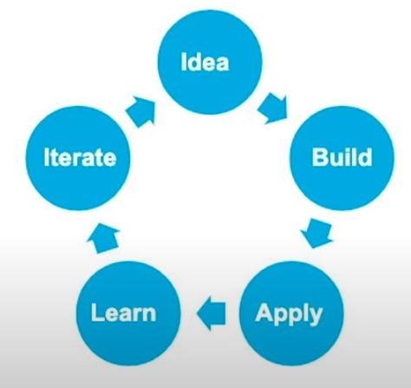
4. **Test, Refine -> Final product**
   1. A lot of different kind of testing need to take place, eg : A/B Testing
   2. After a bunch of iteration of prototyping and testing we’ll be end up with the final product
5. **Release, Measure, Update**
   1. Build the product – should be pretty easy
      1. Translate the requirements and do any operational or security updates
      2. Instrument updates to measure impact and changes
      3. Get it out the product as quickly as possible, don’t block future you(don’t really something you cant iterate on quickly )
   2. Launch the product
      1. Use the metrics from your testing to help marketing
      2. Those upset customers were happy now, get their help
   3. React to new information as you release
      1. You’ll be swarmed with a deluge of product feedback. Totally normal, and your job then is to react to the new information you’re getting
      2. You might miss the edge case scenarios so what you can do now is “**Repeat the process but smaller and more quickly**”
6. Always learning
   1. You’ll pretty much never stop being in this process
   2. The joys of working in artificial intelligence and machine learning is that the industry moves really quickly.
   3. You need to keep on learn so that you manage to react to it and to update what you’re building.

**QUIZ**

Choose the correct statement.

1. Mockup is a wireframe, but with visual design (static)
2. Wireframe is structure and functional requirements (static)
3. Prototype is a mockup, but with interactions (dynamic)
4. Mock up is a prototype, but with interaction (dynamic)